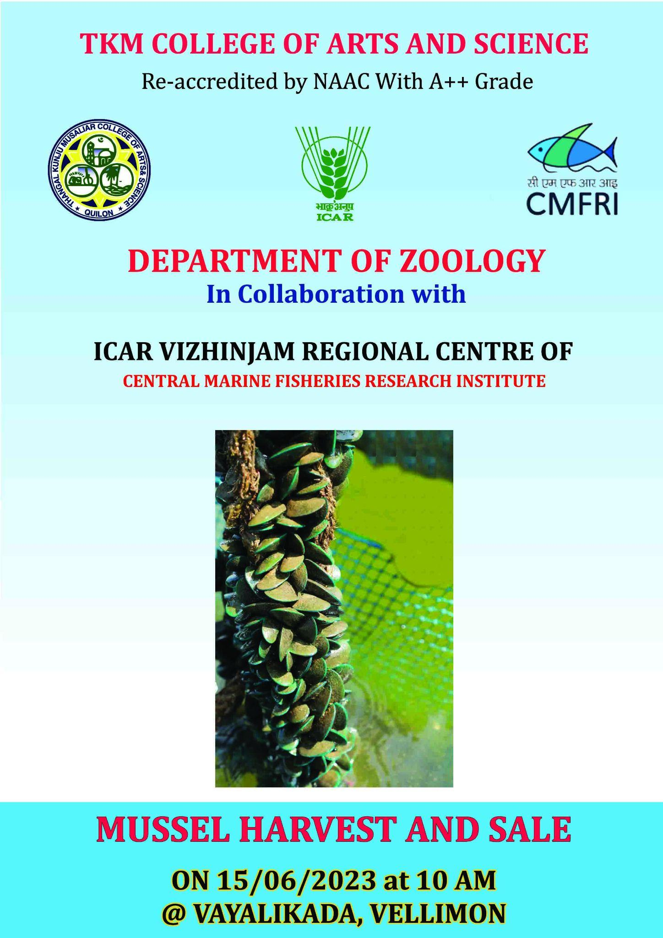

REPORT ON THE HARVEST AND SALE OF MUSSELS AT ASHTAMUDI LAKE
The Department of Zoology conducted the harvest and sale of mussels at Ashtamudi Lake on 15/06/2023 as part of a student start-up project on mussel farming. The Department of Zoology implemented the project in collaboration with the Vizhinjam Regional Centre of Central Marine Fisheries Research Institute (CMFRI). The project's primary objective was to facilitate vocational skill development among students and nurture a habit of earning while learning (the "Earn While You Learn Project).
The student start-up project was coordinated by a self-help group called "ZooAqua TKMCAS," which was formed among SC students of the Department of Zoology. The CMFRI was crucial in funding and supporting all project activities through the SCSP Scheme. Dr. MK Anil, principal scientist from the Marine Biology division, provided coordination and guidance throughout the project.
In December 2022, Mrs. Adhila Abdullah, the Director of the Department of Fisheries, Kerala Government, deposited the seeds required for the mussel farming project. These seeds served as the foundation for the subsequent stages of the project.
The project encompassed several activities to ensure successful mussel farming and the subsequent harvest.
The key activities included:
Mussel Cultivation: The project involved the cultivation of mussels using the seed deposits provided by Vizhinjam Regional Centre of CMFRI. The students and experts employed appropriate farming techniques and closely monitored the growth and development of the mussels at periodic intervals.
Maintenance and Monitoring: Regular monitoring of water quality, temperature, and other environmental factors was conducted to create an optimal habitat for the mussels. This included periodic cleaning, feeding, and removing any potential threats or predators.
Knowledge Transfer: The student members were imparted with valuable knowledge and hands-on training regarding mussel farming techniques, sustainable practices, and overall ecosystem management. This facilitated their vocational skill development.

Participants and stakeholders:
The following individuals and groups actively participated in the project:

College Principal: Dr. Chithra Gopinath
CMFRI Scientists: Dr. M. K. Anil, Principal Scientist, VRC-CMFRI
CMFRI Technical Experts: Mr. Raju, Technical Assistant, VRC-CMFRI
Program Coordinator: Dr. Rohini Krishna M V, Assistant Professor, Department of Zoology
Programme convener: Dr. Jasin Rahman, Head of the Department of Zoology.
Assistant coordinator: Dr. Mumthas Y, Assistant Professor, Department of Zoology
Faculty members: Ms. Shalini M
Student Members:
1. Arjun Krishna - (S4, BSc Zoology)
2. Akhil C - (S4, BSc Zoology)
3. Yadhu Krishnan. S - (S2, BSc Zoology)
4 Abhijith. M - (S2, BSc Zoology)
5. Abhin. R - (S2, BSc Zoology)
6. Abhirag. A. R - (S2, BSc Zoology)
7. VichuVilochanan - (S2, BSc Zoology)
Other students from S2 and S4 BSc Zoology participated in the project.
Outcomes and Achievements:
The harvest conducted on 15.06.2023 yielded significant results and showcased the success of the project. The key outcomes and achievements include:
Skill Development: The student members of the project gained valuable practical experience in mussel farming and acquired essential vocational skills in the field of aquaculture. This hands-on training will contribute to their personal and professional growth.
Sustainable Empowerment: Through the SCSP scheme, this project provided opportunities for marginalized students to actively participate in skill development and entrepreneurship.
Nurturing of Earning Habit: Through this ‘Earn While You Learn’ activity a sense of earning while learning was inculcated in students.
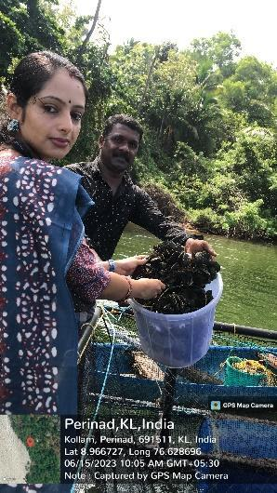 | 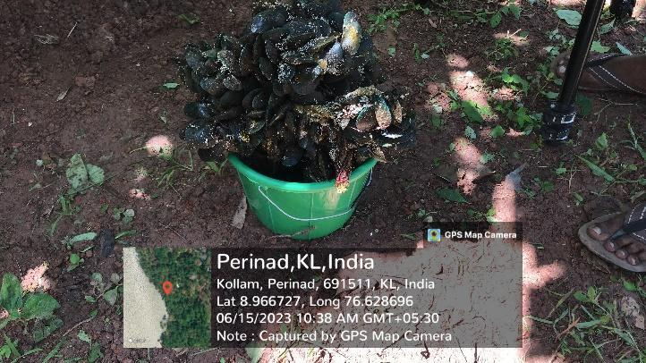
Mussel harvest | Harvested mussel
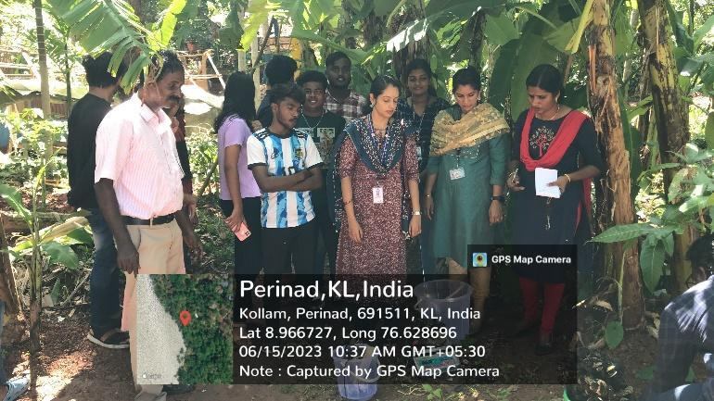 | 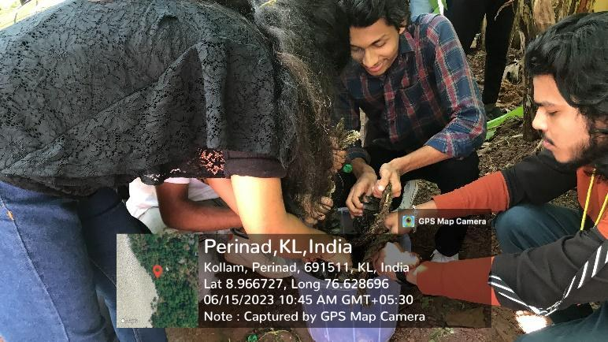
Sorting of harvested mussel | Students taking part in mussel sorting
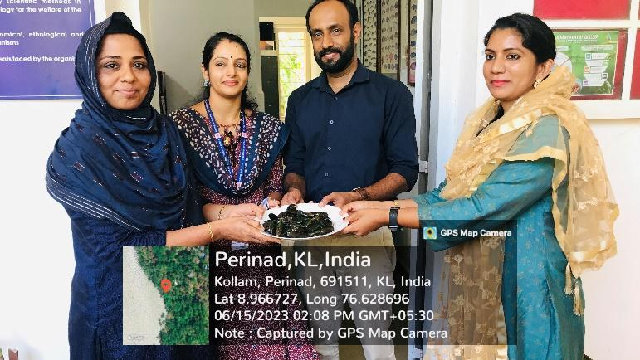 | 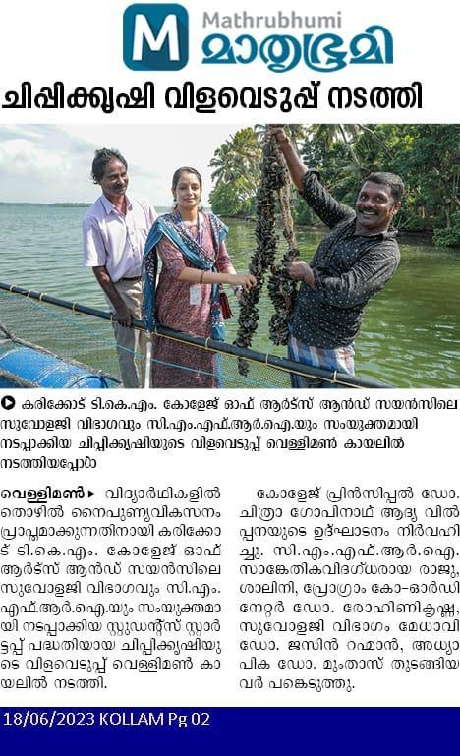
Sale of mussels in college | Mathurbhumi 18/06/23
..
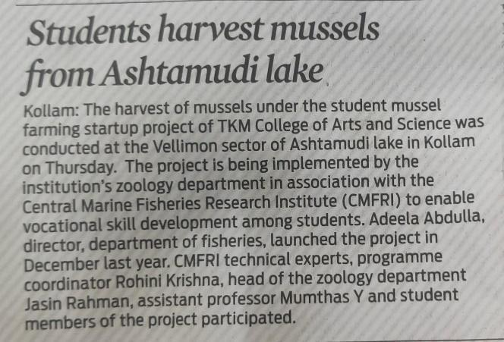 | 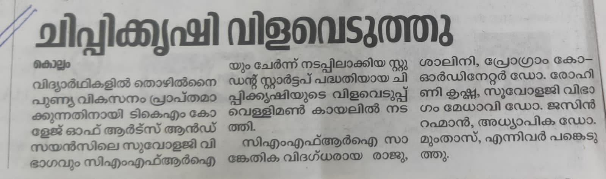
16-06-2023 Indian express | 17/06/23 Deshabhimani
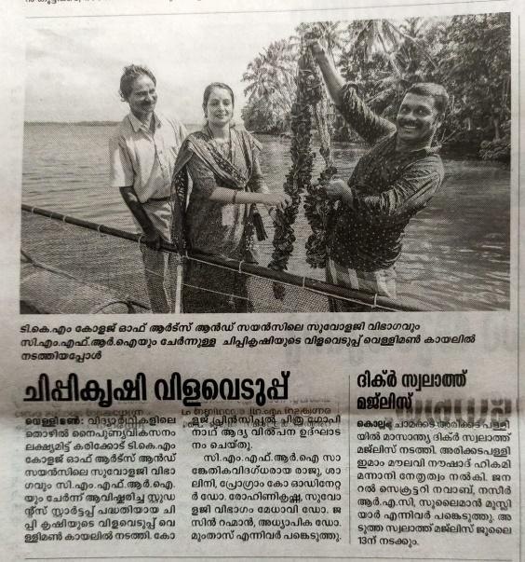 | 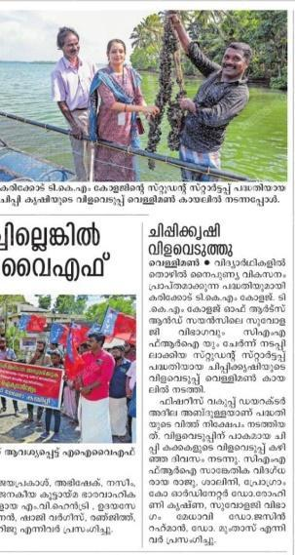
18/06/23 Madhyamam | 19/06/23 Manorama
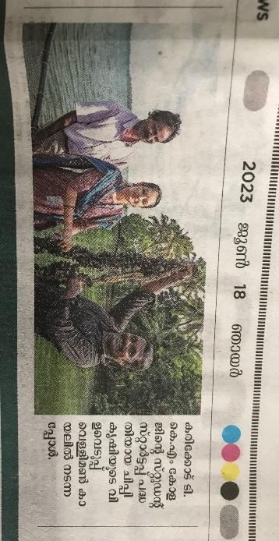 | 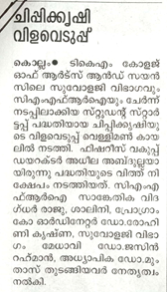
18/06/23 Manorama | 16/06/23 Manorama

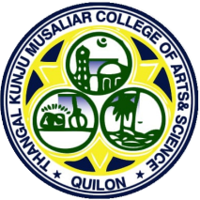
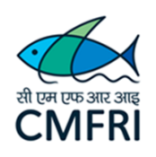
T.K.M. College of Arts & Science, Kollam
DEPARTMENT OF ZOOLOGY
IN COLLABORATION WITH
VIZHINJAM REGIONAL CENTRE OF CMFRI
2nd Stage seeding of cage culture

On 14 ^{th} February 2023

Location: Vellimon sector of Ashtamudy Lake Time: 10.30 am

The department of Zoology, TKM College of Arts and Science, in collaboration with ICAR-Central Marine Fisheries Research Institute (CMFRI), has been carrying out Cage Culture of Pearl Spot (Etroplussuratensis) in the Vellimon sector of Ashtamudy Lake from 18-2-2022 onwards. This is the first Student Project of CMFRI. This Cage Culture farming is the first student Start Up of our college was effectuated by seven SC students of the department of Zoology. 23-12-2022 marked the harvesting and sale of fishes from the cage, and the inauguration of the next batch of integrated multitrophic level aquaculture involving fishes, mussels and edible oysters. On 14-2-2023 the second stage seeding of the cage was carried out.
New members of the group Zooaqua TKMCAS were given training by Aparna J.S, former president of the group. As the final year students from the group were passing out from the college, new members from 1st year were added. The new members and their designations are the following Arjun krishna (II BSc Zoology, President), Akhil. C (II BSc Zoology, Secretary), Yedhu Krishnan (I BSc Zoology, treasurer), VichuVilochanan(I BSc Zoology Member), Abhjith (I BSc Zoology, Member) and Athulya Narayanan (I BSc Zoology Member). Interested students from the I BSc Zoology were also included.

The programme started at 10.30 am and 1500 seeds of Etroplus were transported from a fish trader and deposited in the cage. The fishes were transported in a syntax tank and were transported to the cage from the shore in transparent buckets at the rate of 100 fishes per bucket. The inauguration took place with the initial deposition of the fishes in the cage by the IQAC coordinator and Assistant Professor, Dr.Sumalekshmi. S, this was followed by fish deposition by Dr. Rohini Krishna M V, Assistant Professor, Department of Zoology and programme coordinator, Dr. Jasin Rahman, Assistant Professor and HOD, Department of Zoology and programme convenor, Dr.Mumthas. Y, Assistant Professor, Department of Zoology, Dr. Muhammad Mustafa, Librarian and infrastructure coordinator, Dr. Salini, Faculty, Department of Zoology. The students also participated actively in the fish deposition. Sri B. Raju, Technical Assistant from CMFRI aided in the fish deposition and transportation.
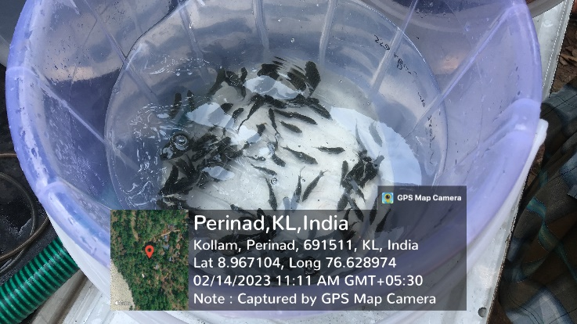 | 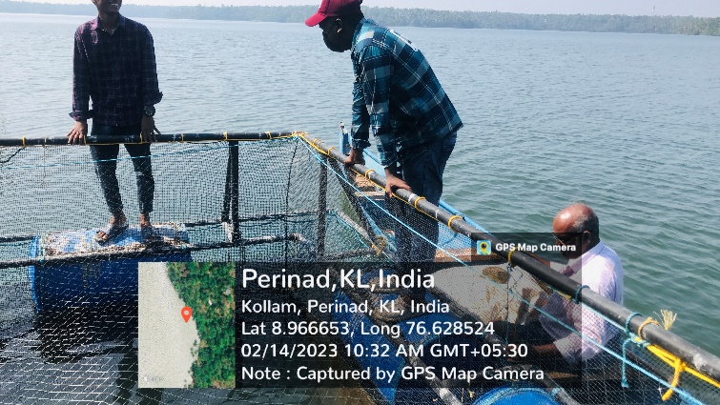
Etroplus seeds for deposition | New members of Zooaqua at the Cage
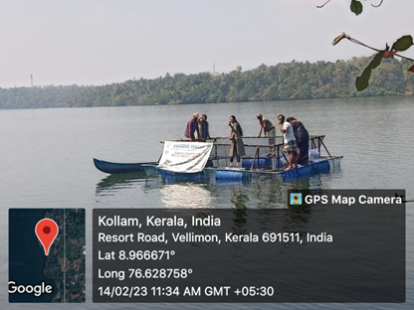 | 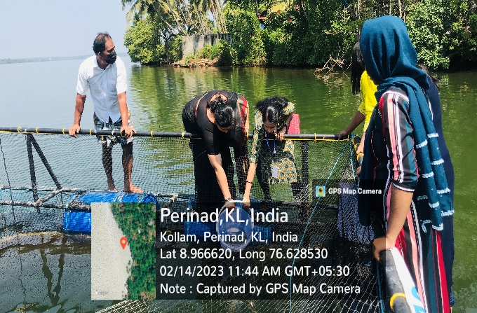
Faculty members at the Cage | Fish deposition by, Dr. Sumalekshmi and Dr. Rohini Krishna.
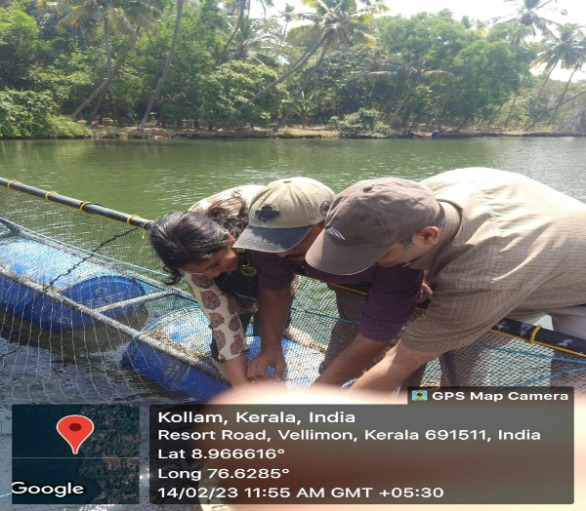 | 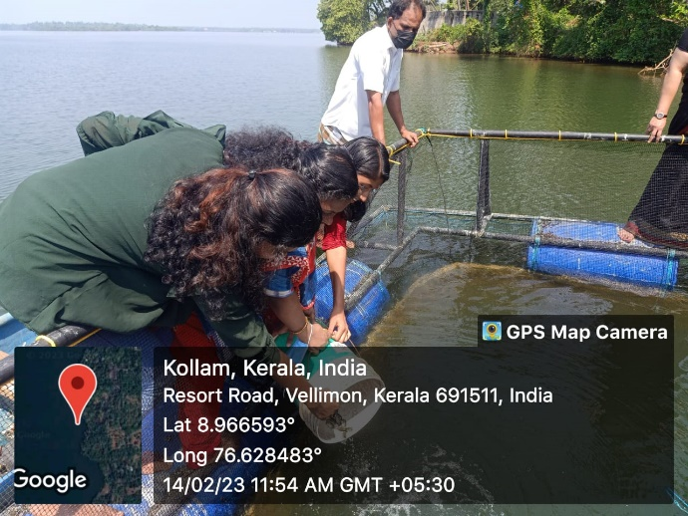
Fish deposition by Dr. Jasin Rahman, Dr Mumthas. Y and Dr. Mustafa | Fish deposition by Dr. Salini and students
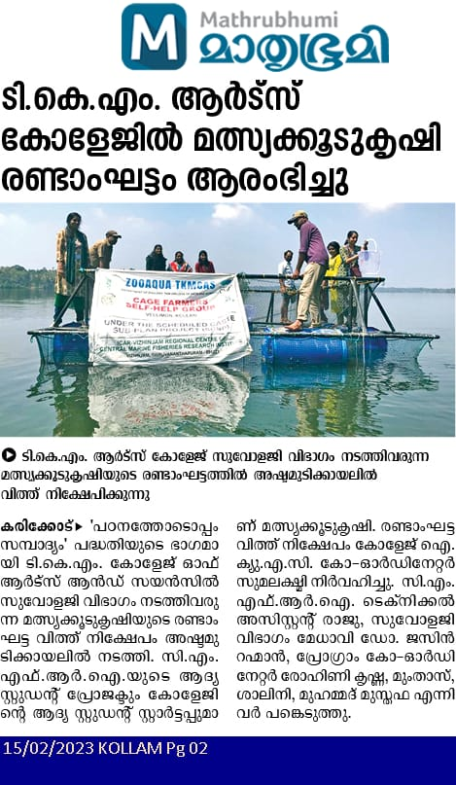 | 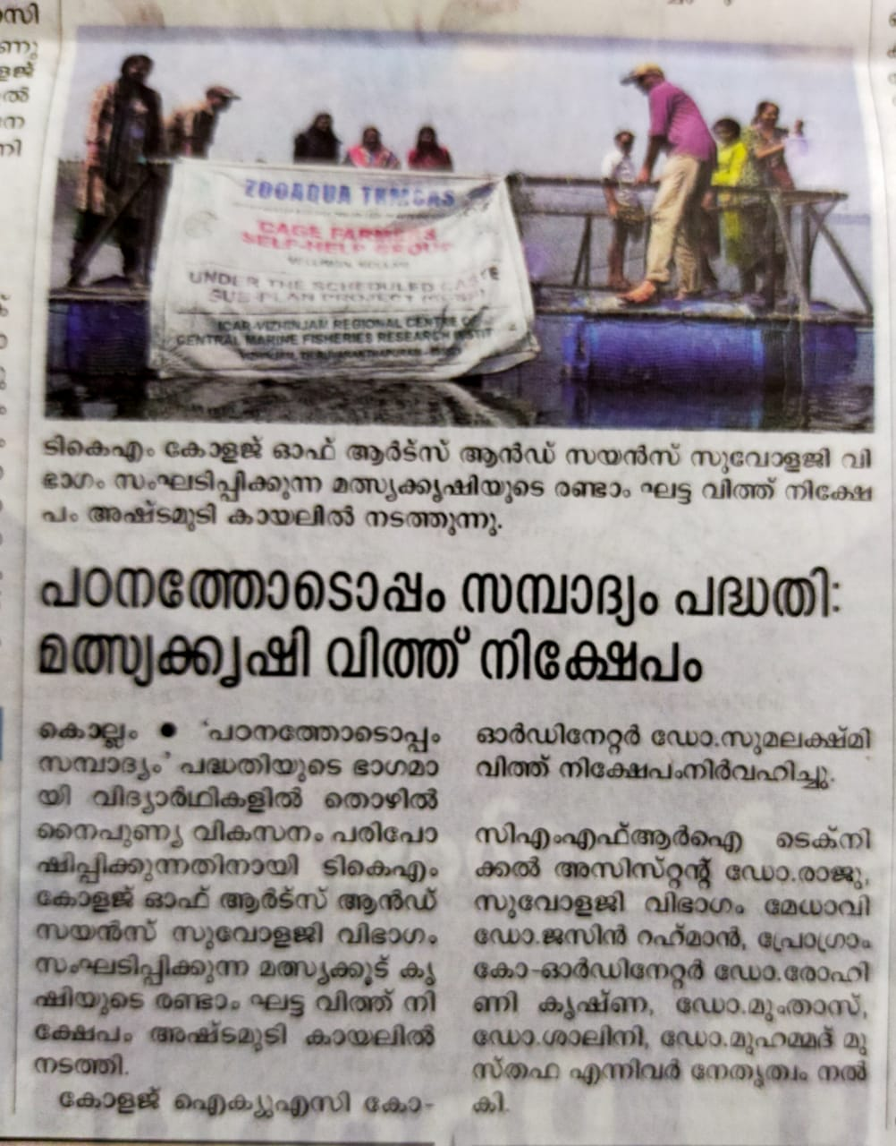
Mathurbhumi 15/02/2023 | Malayala manorama 15/02/2023

Newspaper reports of the event

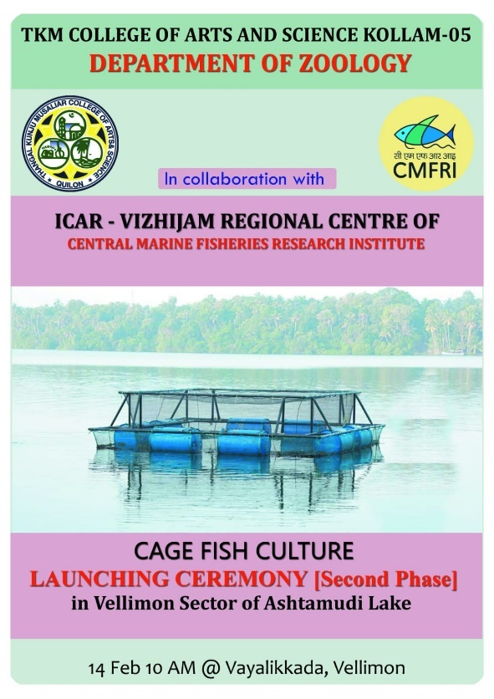

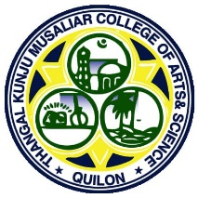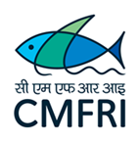

REPORTON
CAGE CULTURE HARVEST AND SALE AND DISTRIBUTION OF MUSSEL AND OYSTER SEEDS

DEPARTMENTOF ZOOLOGY TKM College ofArtsand Science,Kollam
IN COLLABORATION WITH
ICAR- Vizhinjam Regional Centre of CMFRI
The department of Zoology, TKM College of Arts and Science, in collaboration with ICAR-Central Marine Fisheries Research Institute (CMFRI), has been carrying out Cage Culture of Pearl Spot (Etroplussuratensis) in the Vellimon sector of Ashtamudy Lake from 18-2-2022 onwards. This is the first Student Project of CMFRI. This Cage Culture farming is the first student Start Up of our college which is being effectuated by seven SC students of the department of Zoology. 23-12-2022 marked the harvesting and sale of fishes from the cage, and the inauguration of the next batch of integrated multitrophic level aquaculture involving fishes, mussels and edible oysters.
The programme started with the harvest at 7.00 am which was carried out with the help of the local fishermen and technical assistants from CMFRI and project members, faculty and students from the department of Zoology, staff members from TKM CAS, scientist and members from CMFRI and the villagers were present at the event. The fishes collected using a drag net were transported to a boat and were collected in a tarpaulin sheet on the shore. The total catch amounted to about 200 kgs. Out of this 80 kgs were packed in 1 kg polythene bags with the label “Zooaqua TKMCAS” with the weight and price displayed on the bag and were transported to the college by 9.30 am for the sale there. 20 kg of fishes were taken by the fishermen who assisted the catch and the local fisherman who looked after the cage. 100 kgs of fish were sold in the locality. The prize of the fish was fixed as 550 Rs per kg. About 10 kgs of fish were sold for 500 Rs due to fear of spoilage. The sale of fishes at Vellimon ended at 2.30 pm. Publicity for the fish sale was given through newspaper, announcements and whattsapp.

The inauguration of the fish sale took place in the college premises at about 11.00am. Dr. Chitra Gopinath, Principal, TKM College or Arts and Science delivered the welcome address. Dr. M. K. Anil Principal Scientist and Head, Vizhinjam Regional Centre of CMFRI and programme coordinator briefed the audience about the Project. The honourable Chairman of the TKM Trust Dr. T. K. Shahal Hassan Musaliar delivered the presidential address. Sri. V. Abdurahiman, Minister for Fisheries, Sports, Haj and Wakf Government of Kerala inaugurated the event and distributed the certificates to the members of the cage culture and also to the participants. Janab. T.K JalaudheenMusaliar, Treasurer and Governing body Member, TKM College Trust honoured the dignitaries. Dr. Adeela Abdulla IAS (Director of Fisheries) delivered the keynote address and launched the second phase of the project by handing over oyster and mussel seeds to 4 members of the group Zooaqua TKMCAS. Dr. Jasin Rahman (Head of the Department, Zoology and the Convenor of the programme), Dr Swathy Lekshmi P.S, Principal Scientist Vizhinjam Regional Centre of CMFRI and College Union chairman Minil Madhav delivered the felicitations. The programme concluded with the Vote of thanks proposed by the programme coordinator Dr. Rohini Krishna (Assistant Professor, Department of Zoology). The programme came to a close at 12.30 pm. The sale in the college came to a close at 2.30 pm. Out of the 80 kg brought to the college 70kg was sold and 5 kgs were given as token presentations to members and 5 kg to students. The revenue generated after the expenditure was used for the purchase of the seed and feed for the second phase of the project.
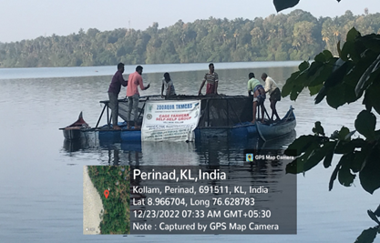  Harvest of fishes from the cage | 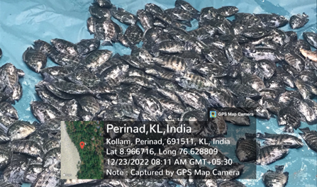  Harvested fishes
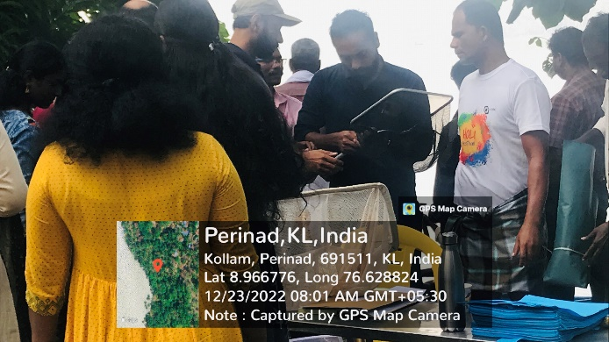  Packaging the fishes for sale | 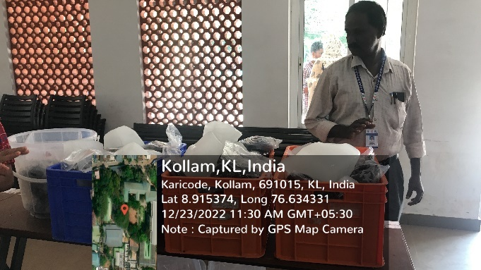  Sales counter at the college
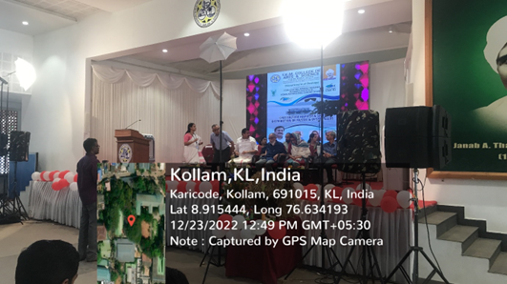  Inauguration of sales | 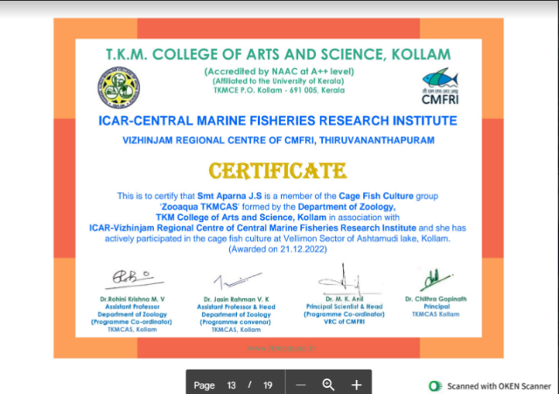  Certificates awarded
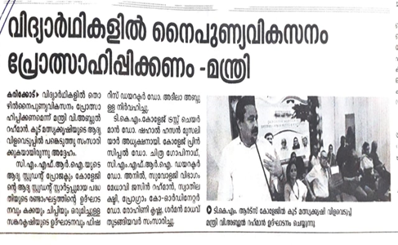  Mathurbhumi 24-12-2022 | 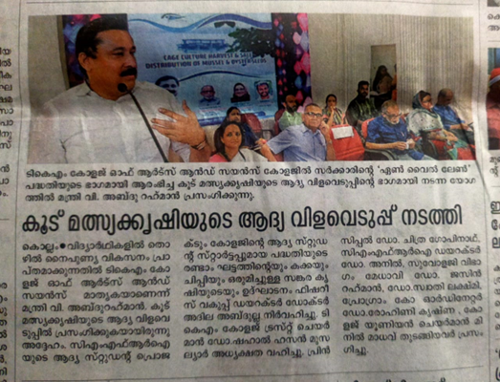  Malayala manorama 24-12-2022

