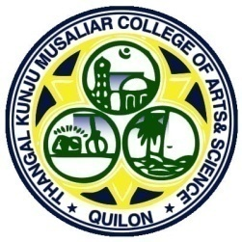
TKM COLLEGE OF ARTS AND SCIENCE, KOLLAM

COMMUNITY OUT REACH PROGRAMMES (COP)

LEND A HANDNURTURE THE SOCIETY

BEST PRACTICE-II

BEST PRACTICE -II
Lend a Hand Nurture the Society

Aims and Objectives
The aims and objectives of COPS are listed below:
Community outreach programs at our college aims to foster a strong connection between the institution and the surrounding community while promoting holistic development.
- Fostering Community Connections: Building strong relationships between the college and the local community through various outreach initiatives.
- Promoting Inclusive Education: Providing educational resources and support to underprivileged and marginalized groups.
- Cultivating Leadership Skills: Encouraging students to develop leadership and communication skills through collaborative projects and leadership opportunities.
- Enhancing Social Wellness: Organizing health-awareness programs, check-up camps, and campaigns to promote overall well-being.
- Environmental Stewardship: Raising awareness about environmental sustainability through activities like tree-plantation drives and water-conservation campaigns.
- Addressing Social Issues: Tackling social issues such as child trafficking, human rights, and child marriage through awareness campaigns and support programs.
- Cultural Enrichment: Encouraging participation in cultural and artistic activities to enrich community life.
- Empowering Students: Helping students become proactive leaders who understand the importance of giving back to society.
These programs aim to create a positive impact on individuals, communities, and society at large by promoting social responsibility and civic engagement.

THE CONTEXT
T.K.M. College of Arts and Science has always regarded community engagement as essential to a well-rounded education. The founder's vision was to shape generations of students who would prioritize societal upliftment over individual gain and success. In 2018, the college formalized and organized its various longstanding community engagements under a single initiative called Community Outreach Programmes (COPS). This initiative is well-coordinated with several central and state government schemes, such as Unnat Bharat Abhiyan, Poshan Pakwada, Swachh Pakwada, and Swachhata hi Seva, NSS, NCC and around 15 clubs, aiming to facilitate community development through the active involvement of both teachers and students.
THE PRACTICE
The college has organized various kinds of initiatives ranging from awareness programmes to relief work during natural disasters. The specifics of the various initiatives are given below.

BLOOD DONATION CAMP

A blood donation camp was conducted at College Auditorium on November 10, 2023, from 9:00
AM to 12:30 PM. The camp aimed to encourage voluntary blood donation and support the needs of patients in government hospitals. The event was organized by the Department of Biochemistry, Health Club, NCC, HDFC and All Kerala Blood Doners Society (KEBS). The blood was collected by the blood bank wing of the Government Medical College, Kollam.

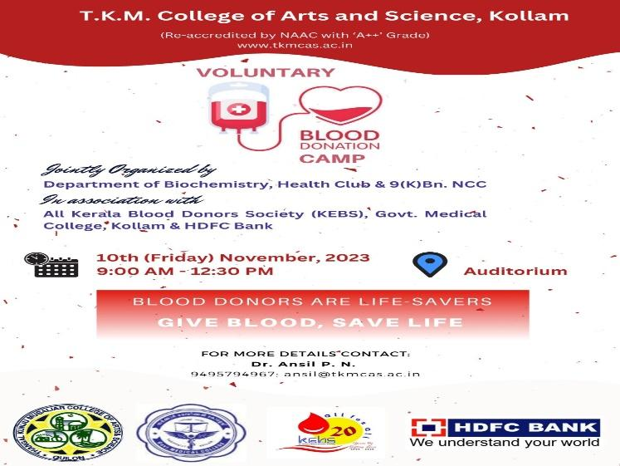

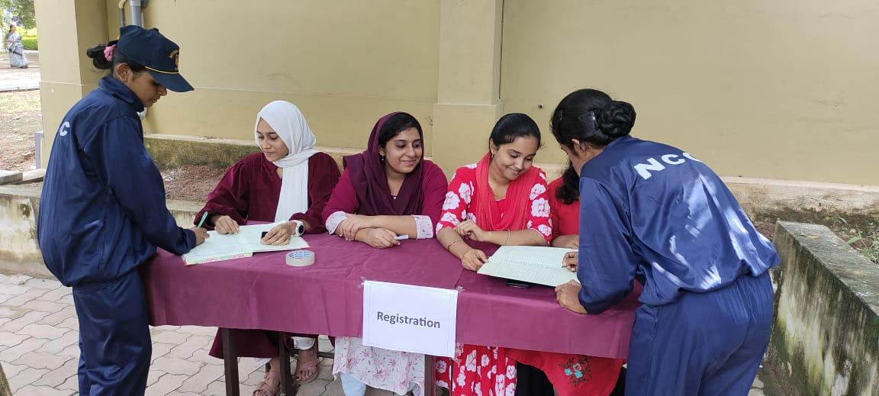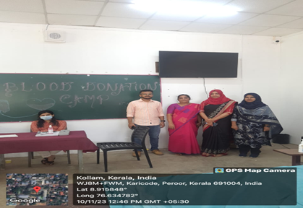

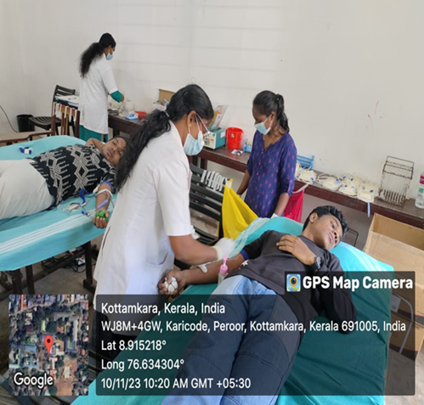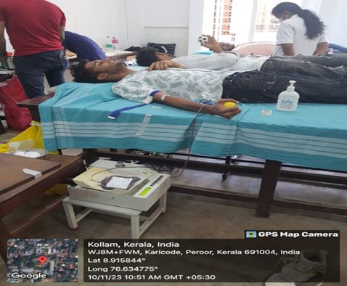
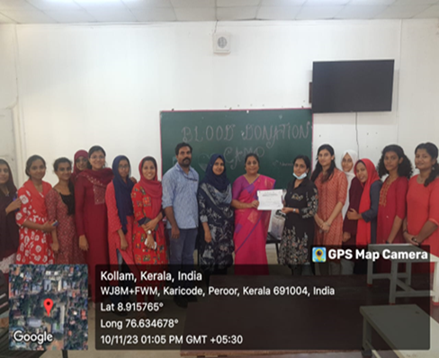

RECOGNITION FOR EXCELLENCE IN VOLUNTARY BLOOD DONATION INITIATIVES

On March 8th, 2024, the Department of Biochemistry, T.K.M. College of Arts and Science, Kollam, was honored by the Kerala Blood Donors Society (KEBS) for organizing numerous successful voluntary blood donation drives. The award ceremony took place at 10:30 AM at the YMCA Hall in Thiruvananthapuram, as part of the 21st anniversary celebration of KEBS.
Dr. Latha B., the Head of the Department of Biochemistry, received the award on behalf of the department. The event was marked by a presidential address delivered by Smt. Lida Jacob, IAS (Retd.). The inauguration and award distribution were conducted by Sri. Sudhir K. IAS, Director of Collegiate Education, Government of Kerala. The specific award received was the Dr. Ruchi Sharma Memorial Blood Donation Award, recognizing outstanding contributions to voluntary blood donation initiatives. The recognition from KEBS highlights the commitment and efforts of the Department of Biochemistry in promoting and organizing blood donation drives, demonstrating a strong sense of social responsibility and community service.
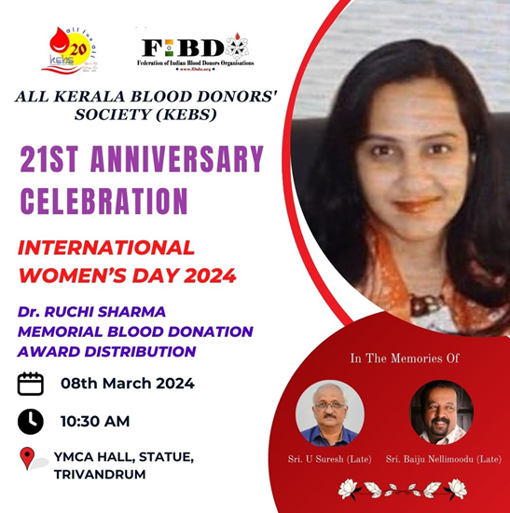 | 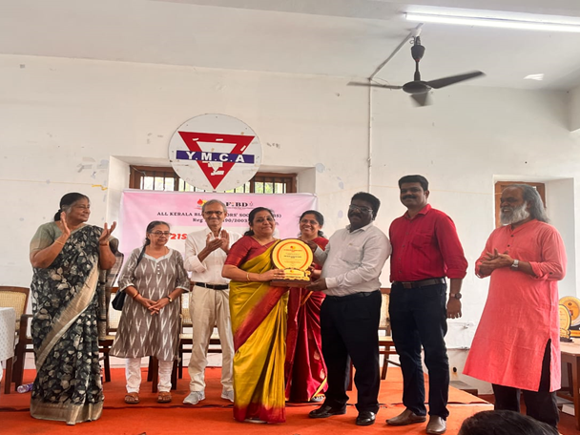  Dr. Latha B. Receiving the Dr. Ruchi Sharma Memorial Blood Donation Award on Behalf of the Department

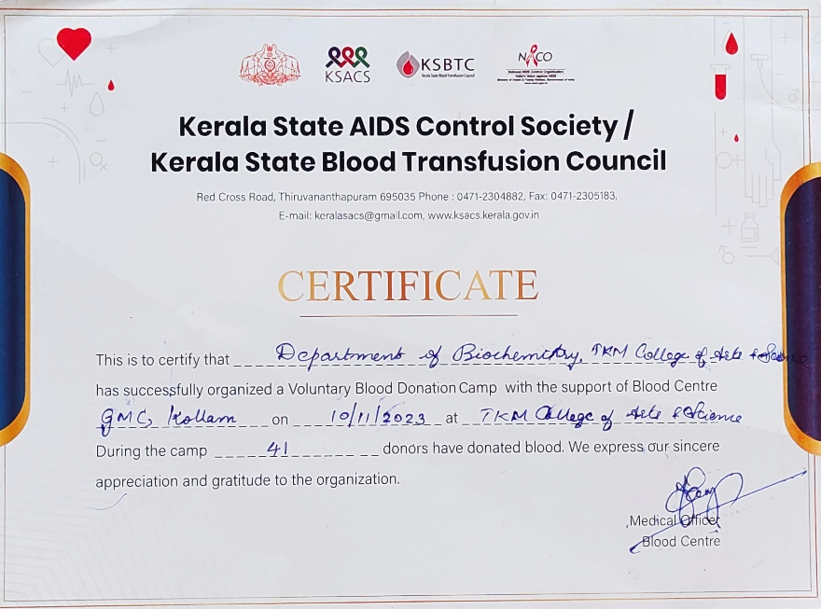

SNEHAPANKU - NOURISH WITH LOVE
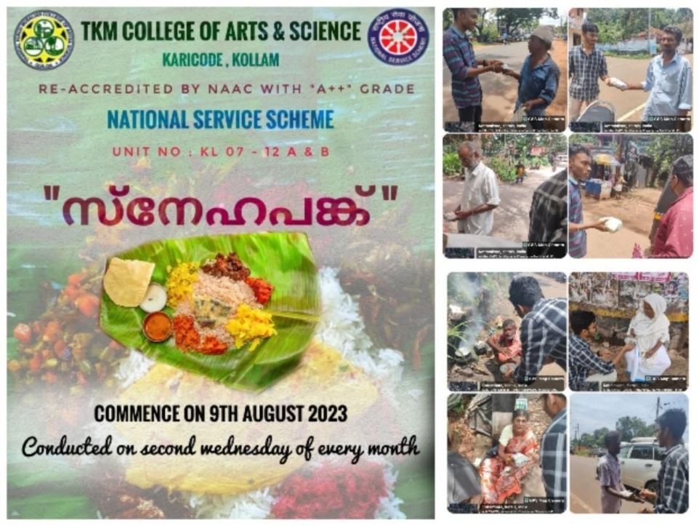
Food is a basic necessity for human life; without it, survival is impossible. However, there are many individuals who struggle to afford even a single meal a day. In recognition of this, our NSS unit decided to launch a new initiative called ‘SNEHAPANKU,’ aimed at providing food to those in need. The program commenced on 9 ^{th} August 2023 and continued throughout the year. This year-long initiative involved collecting food packets from the homes of volunteers and distributing them to people in need. The smiles that appeared on the faces of those we helped brought immense satisfaction to all of us. It also served as a powerful reminder of the value of food and how fortunate we are to have access to it.
tion

VILLAGE ADOPTION

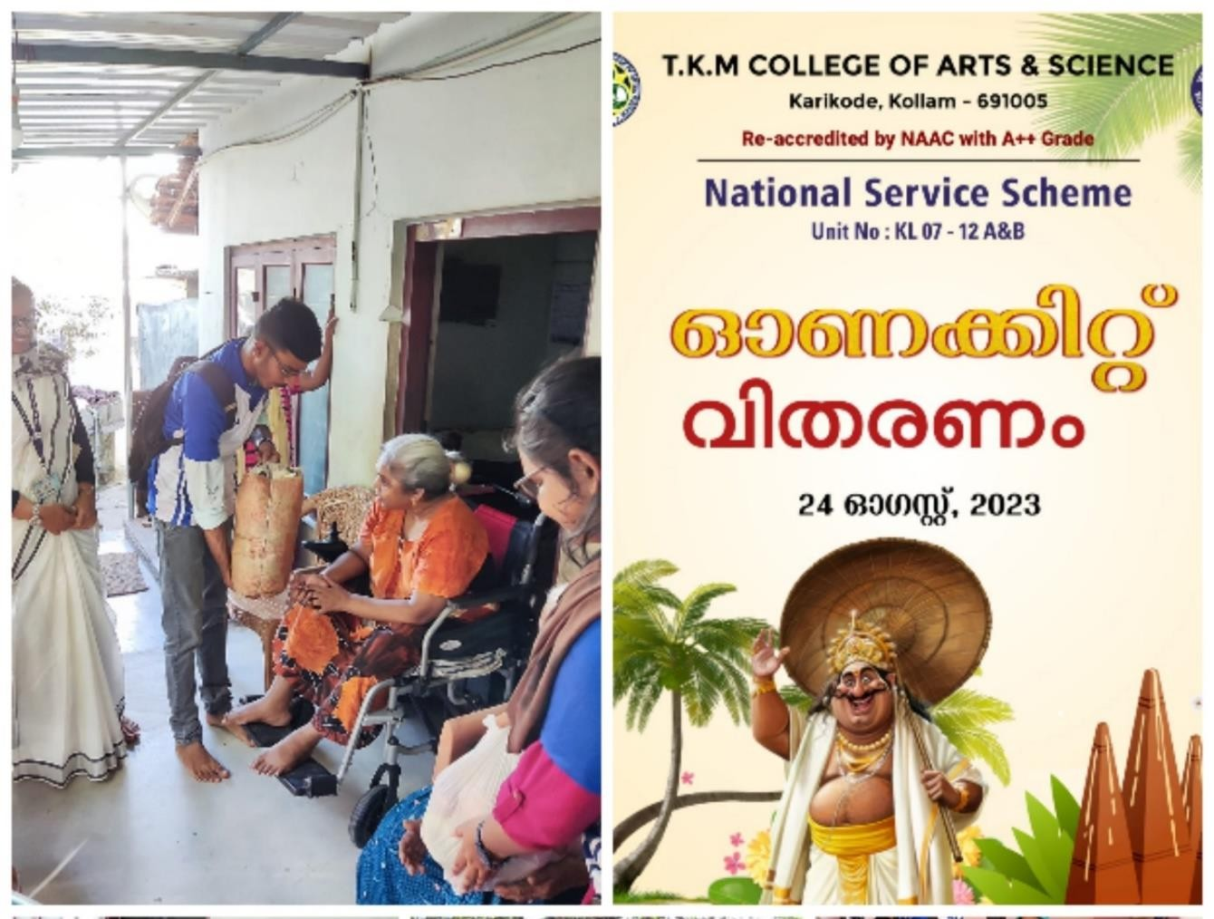Onam is the national festival of Kerala. It is the celebration of harvesting and harmony. These are the days of enjoyment and celebration in each houses of Kerala. But still there are houses where they won’t be able to celebrate as others due to certain reasons. In reality they may also have the longing to celebrate Onam as others. It our responsibility as the fellow beings to understand and help them with the necessary requirements. Taking this into consideration the NSS unit of our college had decided to help such needful people around us in our adopted village. On visiting their homes we were so satisfied with the fact that we had not only considered us during this great time of festivity but others too.

GANDHI BHAVAN ONAM VISIT
NSS unit if our college had decided to spent our onam with the residents of Gandhibhavan, Kottamkara, Kollam. We went to see them with gifts that we could provide them. We had spent a lot of time with the people there. The mothers and fathers present there shared there Onam memories and how they used to celebrate in olden days. They were overwhelmed with emotions which can be identified from their words and their eyes. It shared their emotion. How they missed their family it was clearly evident from their stuttering voice.

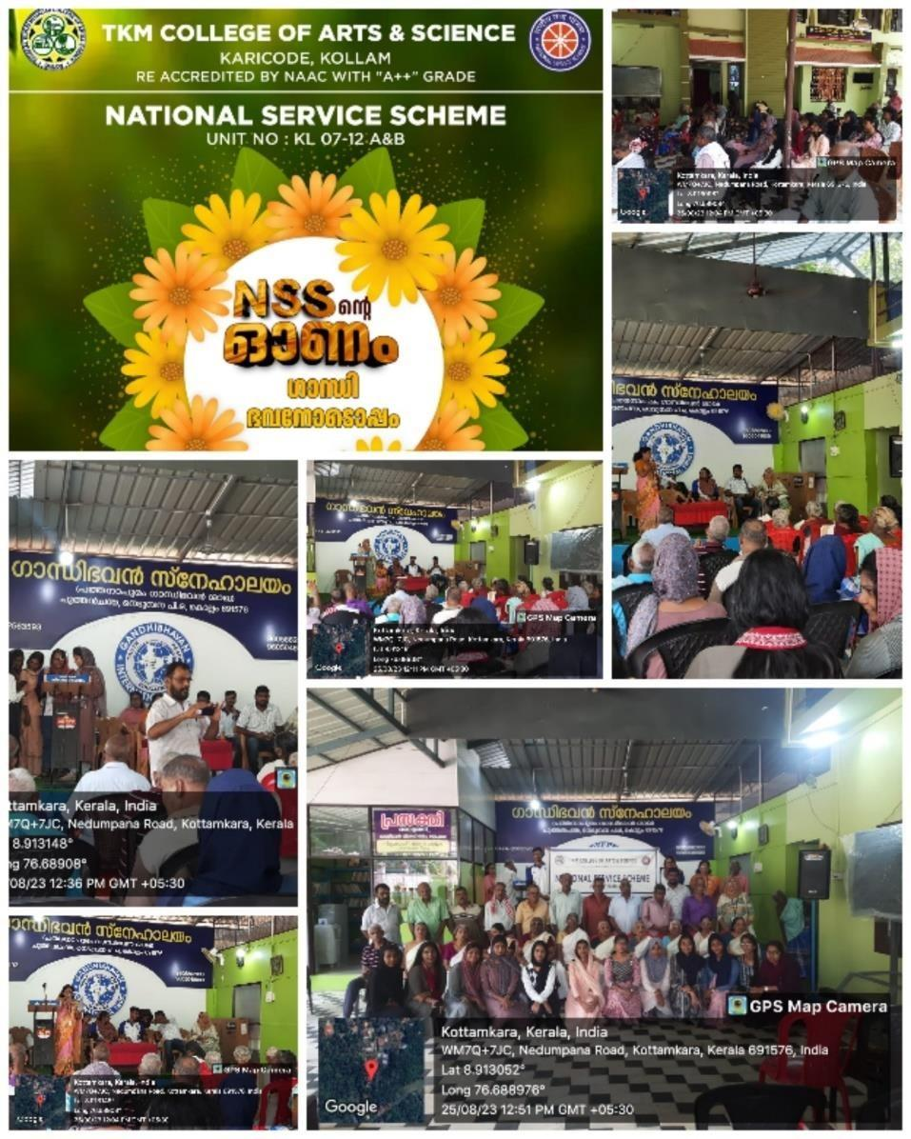

ARTIFICIAL LIMP FITTING CAMP

Our NSS unit in association with Rotary club, Thangasherry and Kims Health Centre had organized a free artificial limp fitting camp at our college. The entire necessities required for the smooth running of camp was arranged by the volunteers of our college. It was a free limp fitment camp for about 60 patients, who are really needful. The first phase camp was to do a medical checkup for the beneficiaries by expert doctors from Kim’s and to take the measurement of their limp that is to be casted. The official inauguration of the camp was done by our principal Dr. Gopinath. Our program officer Dr. Sulfiya Samad, the official of rotary club and the doctors from Kim’s hospital delivered the felicitation. The satisfaction that all our volunteers gained through such an activity was really filling our hearts. Eagerly watching forward for more such actions.

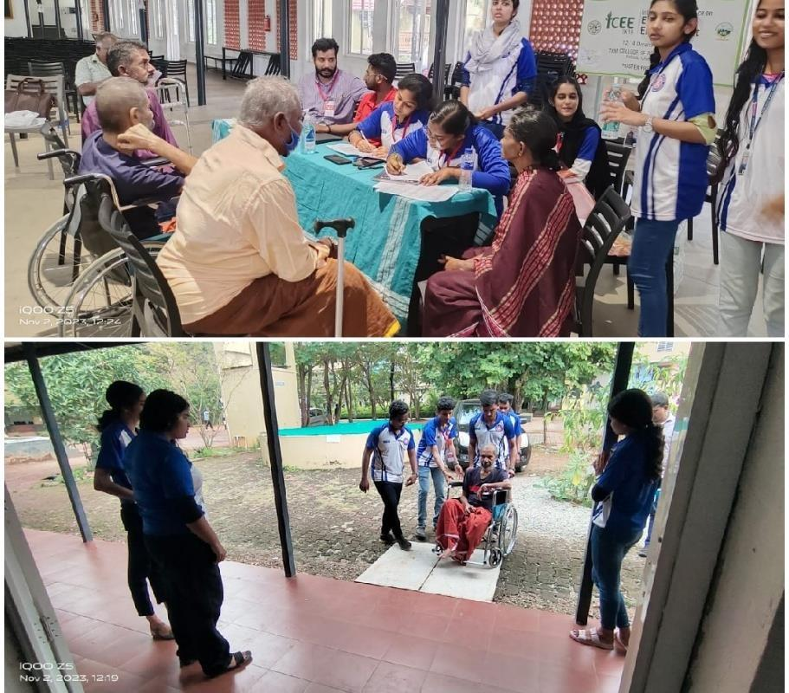
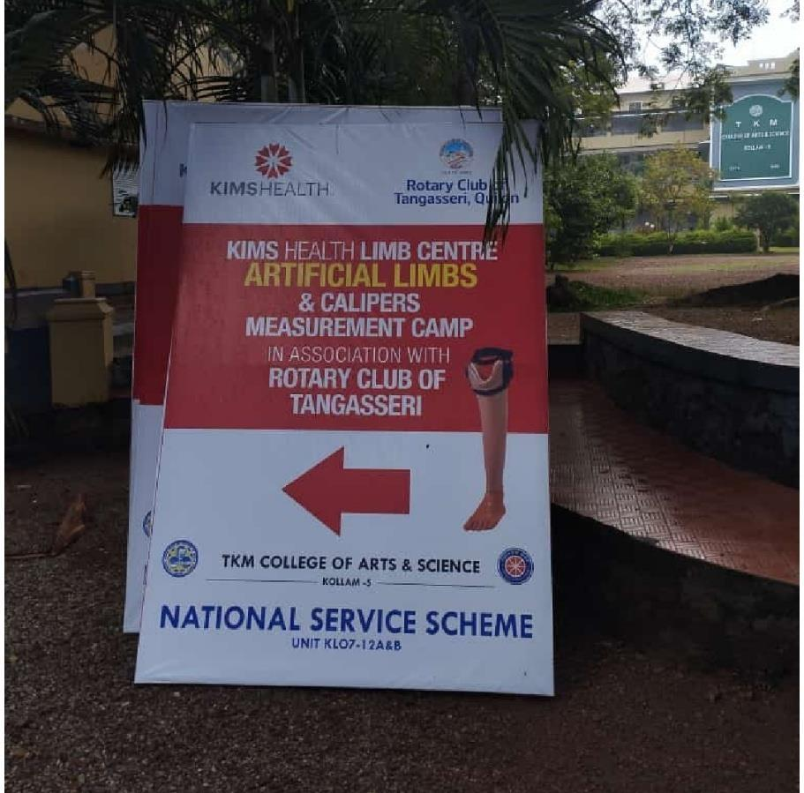

PALLIATIVE CARE TRAINING, VISIT AND
GROCERIES SUPPLY

Palliative care has always been the major area of activity of NSS. Proper training always make us enable to act wisely and accurately in perfect time. Our senior volunteer Adarsh Alex, who got an intensive training by participating in state level Palliative training camp. It was an online training program which was led by volunteer Adarsh.

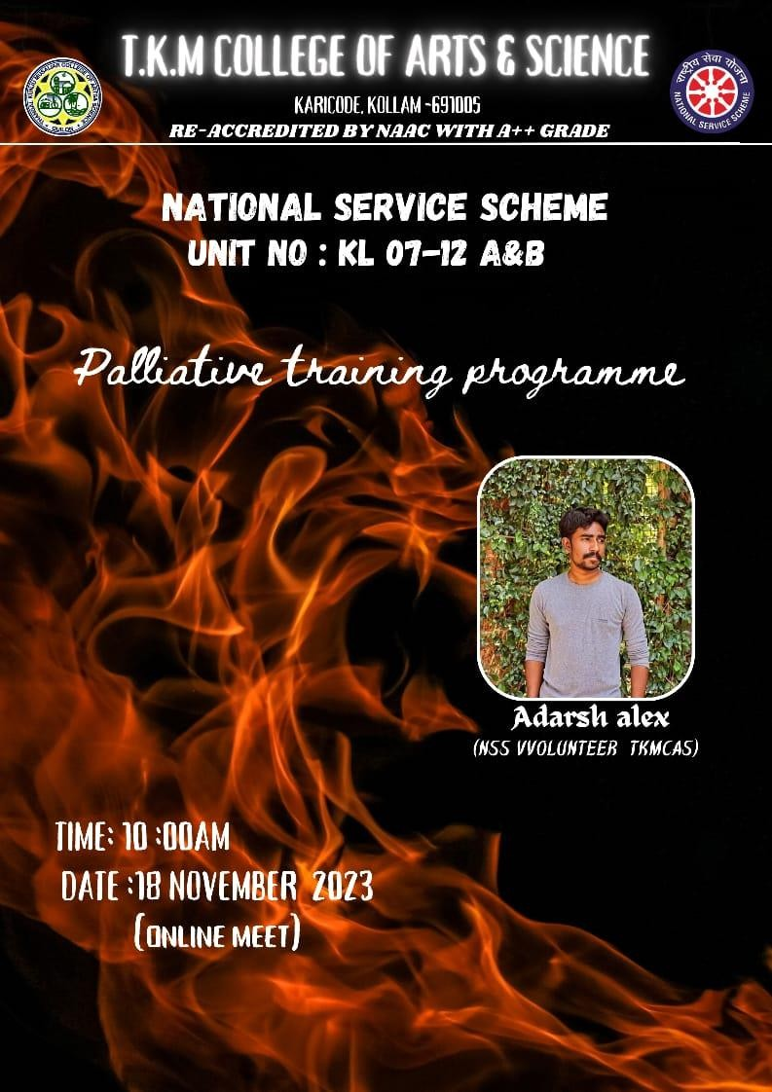
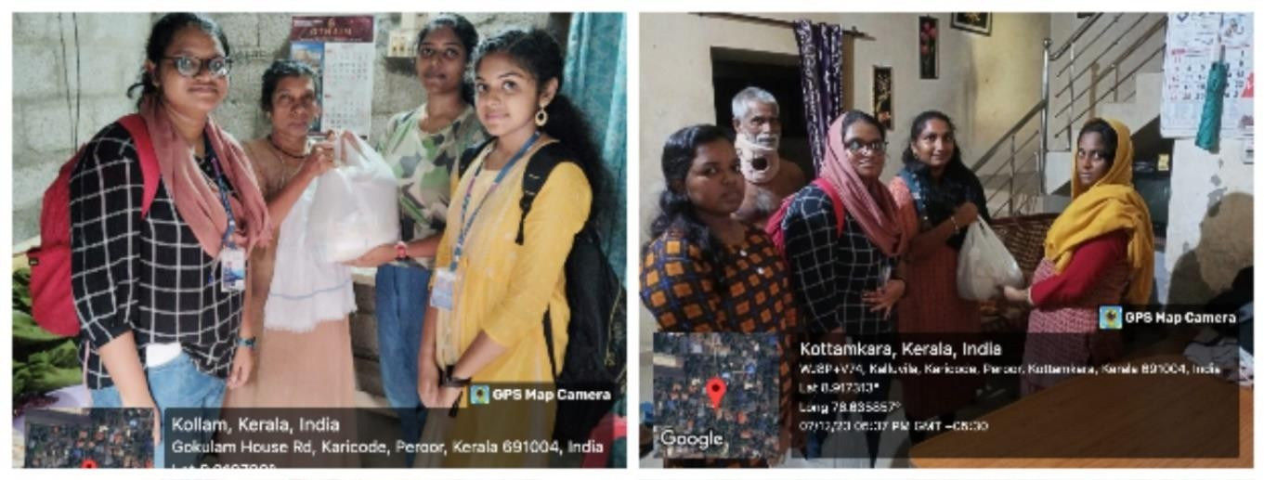

There are a lot of people around us who are even being neglected by the authorities but are really needed to be given concern. Several such persons are around us and do need our help. Through the survey on Palliative day we came across certain people in our adopted village who really needs our help even to meet the daily necessities.

WHEEL CHAIR DONNATION

As per the needs put forward by the needful ones on our last home visit, we had arranged a wheelchair. At 4 pm we visited the house of the beneficiary along with our principal. Principal Dr. Chitra Gopinath had done the handing over of the wheelchair.
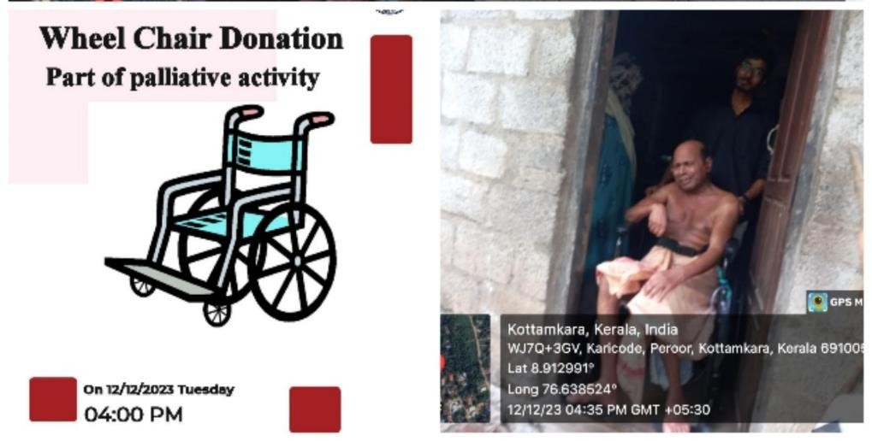

ARTIFICIAL LIMB FITTING CAMPRotaryClub)
Humanity at its peak is always a peace to all humans to believe and appreciate the existence of kindness. As the humans consider others too, the arising of selfless service occurs. Selfless services and impactful activities are two way gifts, which provides happiness to ones who does service as well as to the ones who receive it. Moreover it will also be a encouragement for others to get involved in such activities.
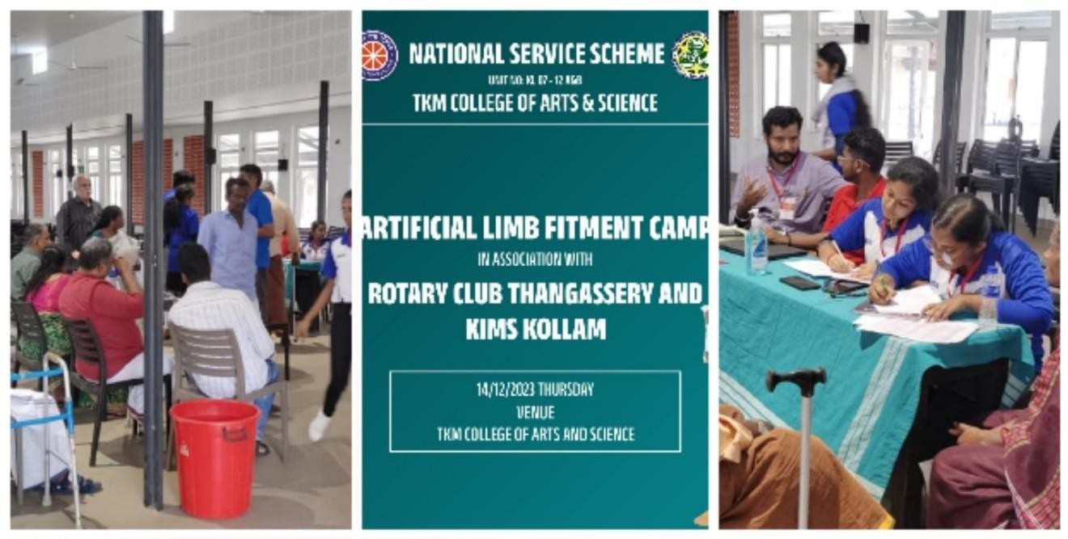

The second phase of Artificial Limp Camp organized by our NSS unit in association with Rotary club, Thangasherry and Kim’s health care was conducted on 14th December. Followed by the welcome speech delivered by the chairman of Rotary club Listing Fernandez. The presidential address was rendered by Georgy Philip, President rotary club Thangasherry. The chief guest of the function was Dr. Mubarak Pasha, Vice - chancellor, SN open university. He inaugurated the event and rendered inaugural address. The keynote address were delivered by Alex Koshy, District secretary General rotary club, Dr. Chitra Gopinath, principal, TKM College of Arts and Science and Dr. Aneena Fatima, consultant Kim’s limp Centre. Then the other dignitaries on the dias delivered felicitation speech. Then the meeting came to an end with the vote of thanks.

CAGE CULTURE FARMING FIRST STUDENT START UP
SC-ST STUDENT PROJECT
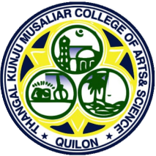
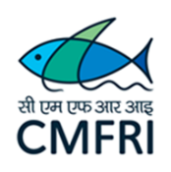

T.K.M. College of Arts & Science, Kollam

DEPARTMENT OF ZOOLOGY
In collaboration with
VIZHINJAM REGIONAL CENTRE OF CMFRI
2nd Stage seeding of cage culture

Location: Vellimon sector of Ashtamudy Lake Time: 10.30 am
The department of Zoology, TKM College of Arts and Science, in collaboration with ICAR-Central Marine Fisheries Research Institute (CMFRI), has been carrying out Cage Culture of Pearl Spot (Etroplussuratensis) in the Vellimon sector of Ashtamudy Lake from 18-2-2022 onwards. This is the first Student Project of CMFRI. This Cage Culture farming is the first student Start Up of our college was effectuated by seven SC students of the department of Zoology. 23-12-2022 marked the harvesting and sale of fishes from the cage, and the inauguration of the next batch of integrated multitrophic level aquaculture involving fishes, mussels and edible oysters. On 14-2-2023 the second stage seeding of the cage was carried out. New members of the group Zooaqua TKMCAS were given training by Aparna J.S, former president of the group. As the final year students from the group were passing out from the college, new members from 1st year were added. The new members and their designations are the following Arjun krishna (II BSc Zoology, President), Akhil. C (II BSc Zoology, Secretary), Yedhu Krishnan (I BSc Zoology, treasurer), VichuVilochanan (I BSc Zoology Member), Abhjith (I BSc Zoology,Member) and Athulya Narayanan (I BSc Zoology Member). Interested students from the I BSc Zoology were also included. The programme started at 10.30 am and 1500 seeds of Etroplus were transported from a fish trader and deposited in the cage. The fishes were transported in a syntax tank and were transported to the cage from the shore in transparent bucketsat the rate of 100 fishes per bucket.

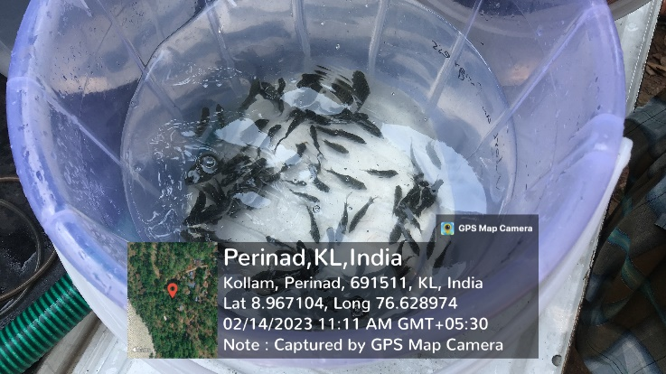 | 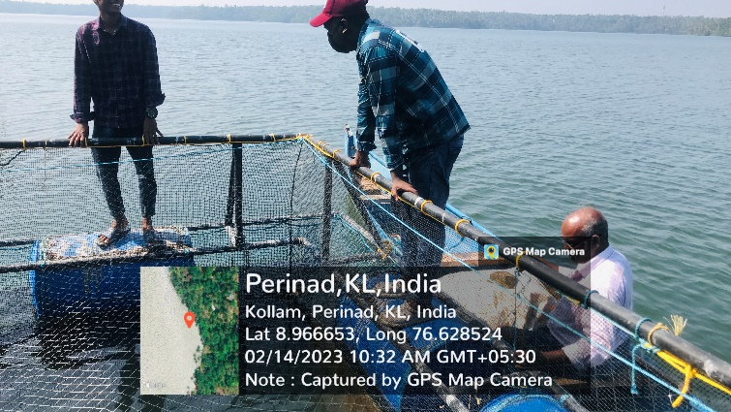
Etroplus seeds for deposition | New members of Zooaqua at the Cage
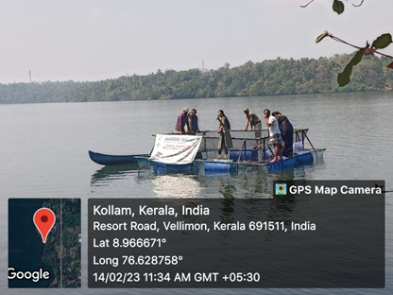 | 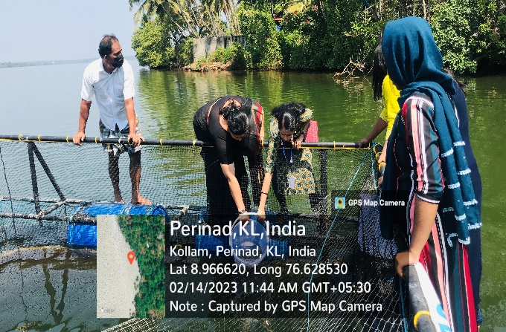
Faculty members at the Cage | Fish deposition by, Dr. Sumalekshmi and Dr. Rohini Krishna.
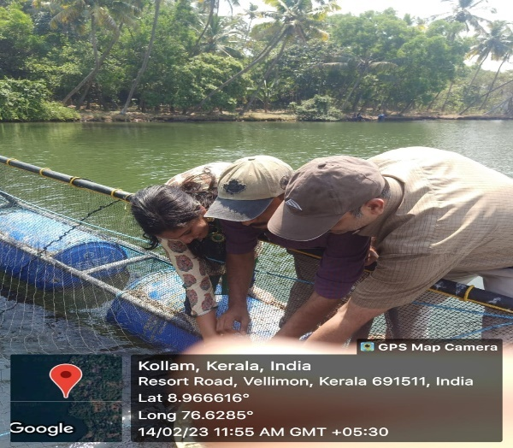 | 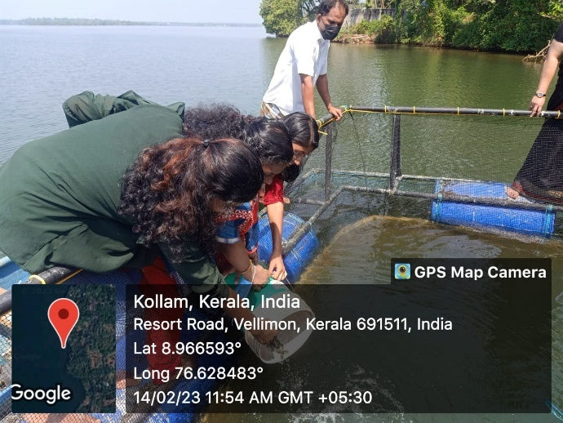
Fish deposition by Dr. Jasin Rahman, Dr Mumthas. Y and Dr. Mustafa | Fish deposition by Dr. Salini and students
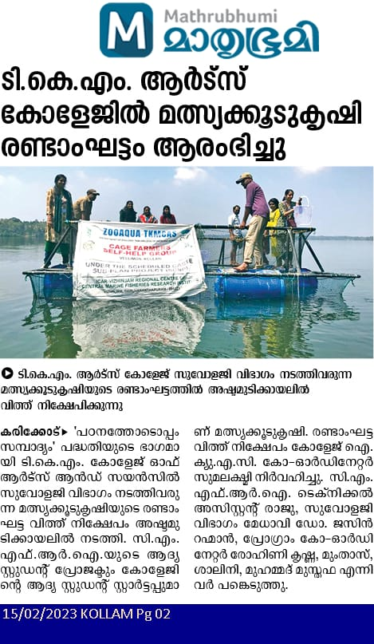 | 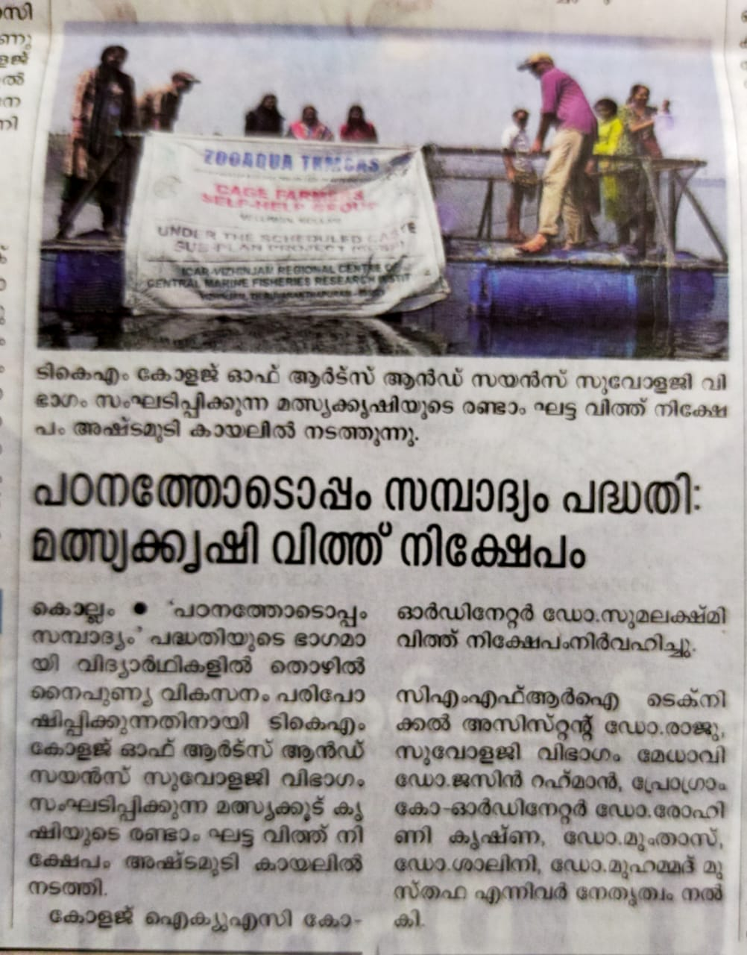
Mathurbhumi 15/02/2023 | Malayala manorama 15/02/2023

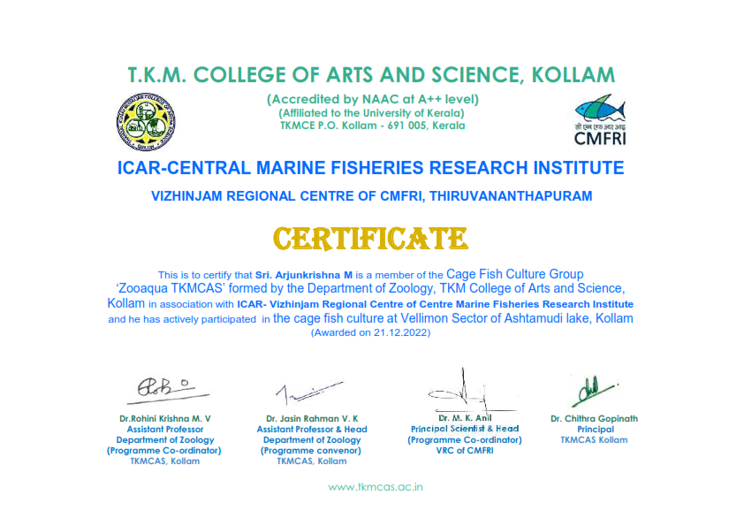

HAPPY KOLLAM PROJECT’

The ‘Happy Kollam Project’ at our College is an initiative aimed at promoting mental health and well-being among students. Launched in collaboration with the Nila Foundation. The primary goal of the project is to prevent suicides by providing mental health support and counseling to students. It also aims to create a supportive campus environment where students can openly discuss their mental health issues without fear of stigma. The project involves selected student volunteers and NCC cadets who will lead various activities and programs.

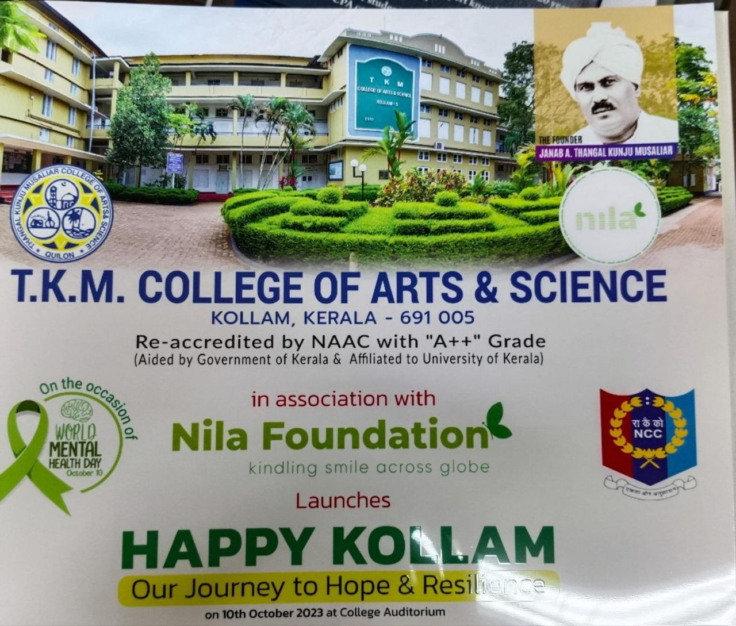

3 Kerala Girls Bn NCC in collaboration with NILA foundation launched Happy Kollam Project on October 2023.This team envisage suicide free campus building the vision of happier and more resilient Kollam.20 cadets of 3 Kerala girls participated in the program.
