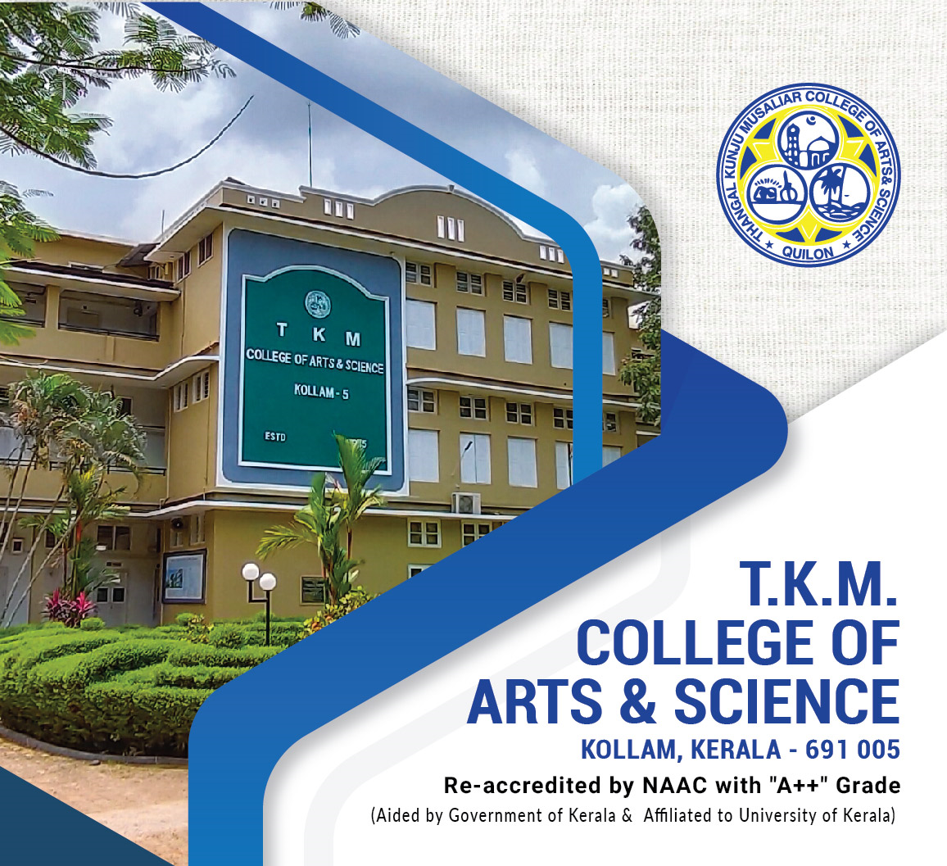
Best Practice I

BEST PRACTICE I
Academic Interventions Initiatives (AII) “Educate to Empower”
Epitomises the vision and mission of the institution
Centralised initiative to streamline the efficacy of various academic activities and reforms
Objectives
- 100 per cent ICT infiltration in classrooms
- Reforms to facilitate student progression into higher education/research
- Orienting classroom learning towards skill and employability enhancement
- Additional support for underprivileged students – monetary, educational resources, IT facilities access etc.
Context
As a nation, India is moving towards a knowledge economy and society. Since 2014, the Government of India and MHRD has focused on moving the higher education sector towards a more multidisciplinary orientation while guaranteeing increased access, equity and inclusion. T. K. M. College of Arts and Science envisaged the aims and objectives of the Academic Interventions Initiatives taking this vision of the Central Government into account.
Practice
Academic Interventions Initiative (AII) – includes strategies and measures instituted to enhance the efficacy of the teaching-learning process and faculty empowerment programmes. The institution adheres to the UGC/NAAC/University stipulated outcome-based blended learning. Even before the onset of the pandemic, the college, under the aegis of the IQAC, had taken steps to supplement regular classroom teaching with ICT tools. The steps include:

- Upgradation of LMS from Campus Technology to Campus Genie which provides the facilities for timetable generation, hosting live classes, online examination, add-on courses, access to additional educational resources

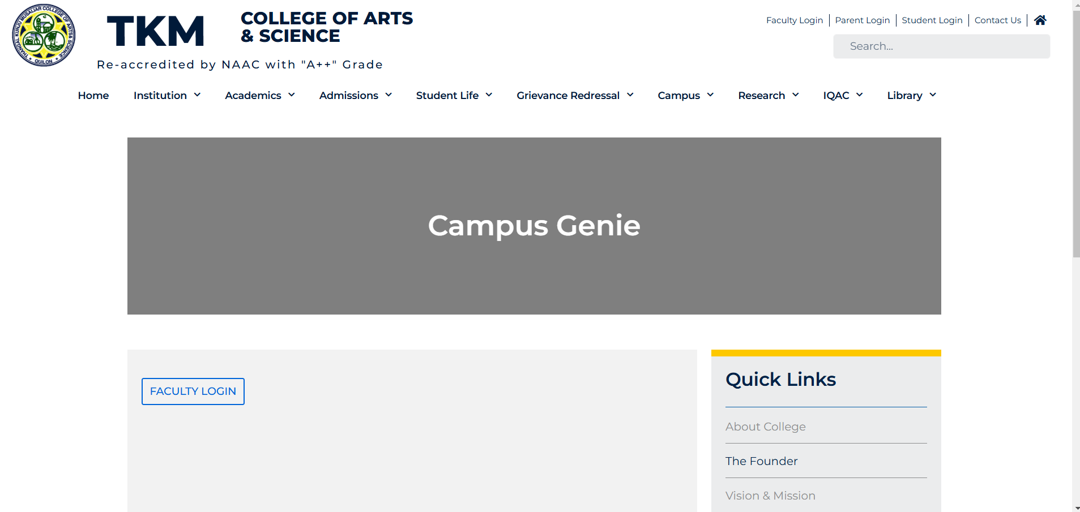

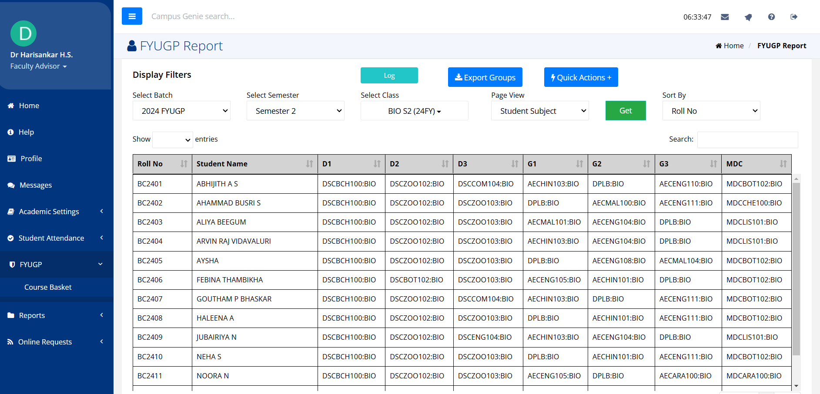

- Certificate Courses specifically designed to enhance student employability

- Organization of faculty training programmes to educate faculties about various online educational resources and platforms.

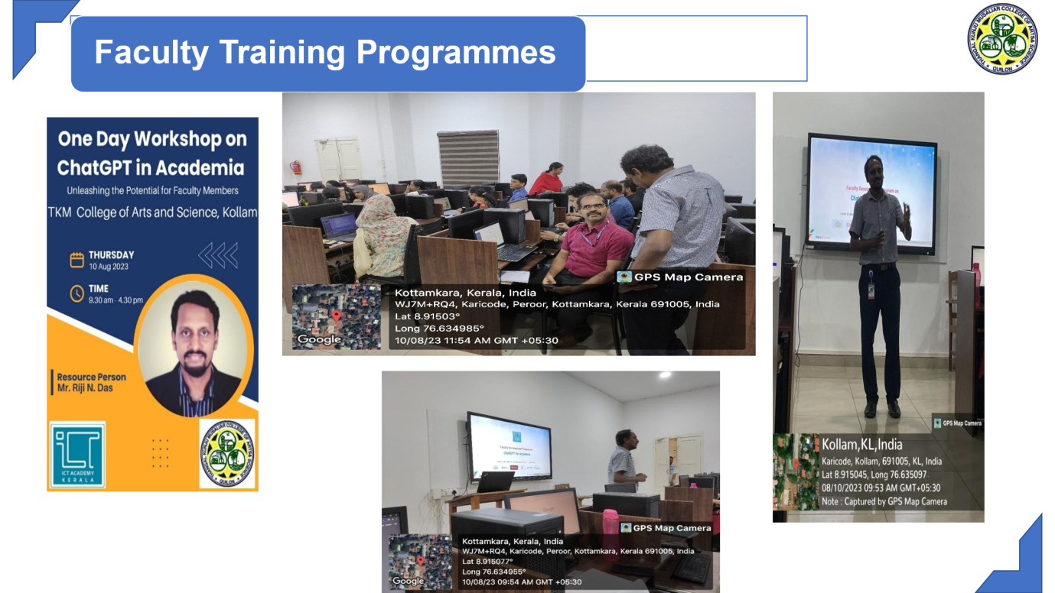

- Academic Enhancement Programmes (AEP)

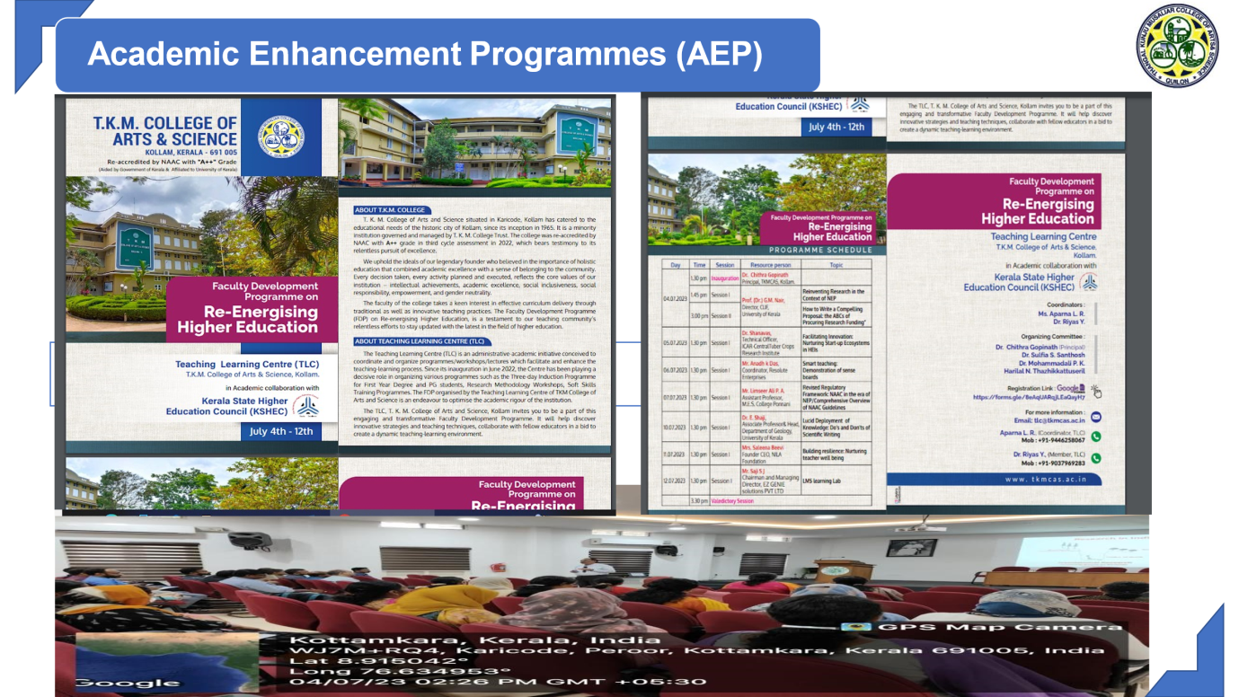

- IQAC-led Research Initiatives (IRIS)

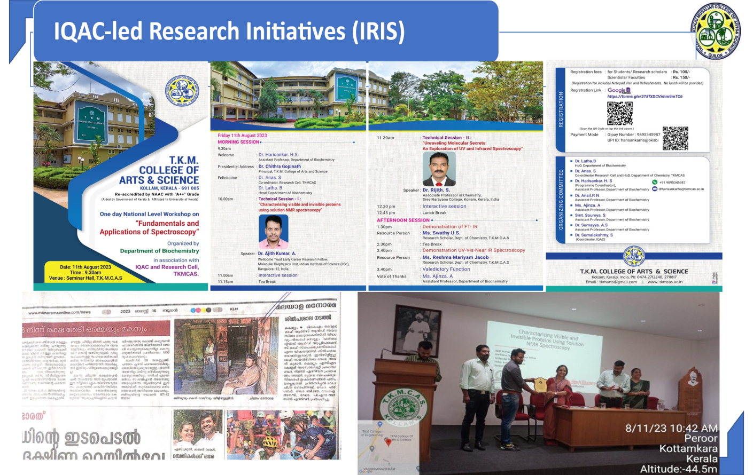
Reinventing Research in the Context of NEP

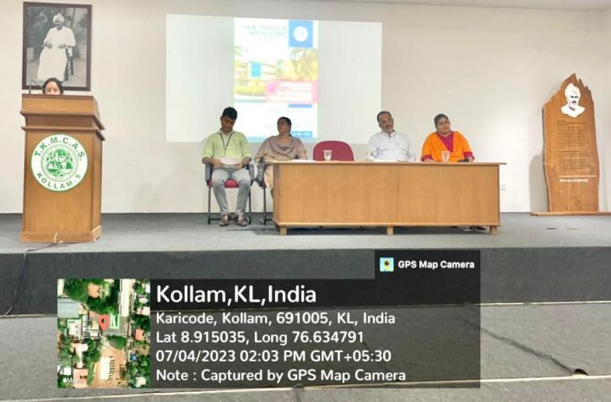
How to Write a Compelling Proposal: the ABCs of Procuring Research Funding

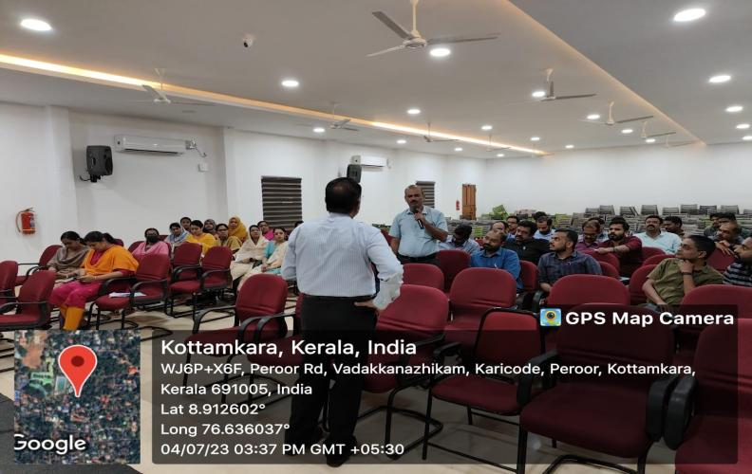

COUNSELLING ASSISTANCE AND RESOURCES FOR EDUCATION (CARE)

Counselling Assistance and Resources for Education (CARE) exclusively caters to the needs of slow learners by providing them assistance with lab sessions, mock tests, and additional learning materials. The CARE project embodies a thoughtful and inclusive approach to student development. Addressing different academic and personal growth aspects fosters a learning environment where all students can thrive.

- Mentor-Mentee Coaching
This strategy is pivotal in building meaningful relationships between mentors and mentees. It can include regular check-ins, goal-setting sessions, and life skills coaching. Effective mentor-mentee coaching helps students navigate academic challenges and provides emotional support, encouraging personal growth and resilience.
- Remedial Classes
These sessions can be tailored to focus on specific subjects or skills where students face difficulties. Incorporating varied teaching methodologies, such as interactive lessons, practice exercises, and peer learning, can enhance the effectiveness of remedial classes. Frequent assessments can help track progress and adjust strategies as needed.
- Support for Slow Learners
Personalised learning plans are crucial here. These include one-on-one tutoring, adaptive learning tools, and access to learning aids like videos and interactive modules. Encouraging a growth mindset and recognizing small achievements can significantly boost confidence and motivation.
- Workshops and Skill Development: Adding workshops on study skills, time management, and stress management can help students build holistic abilities.

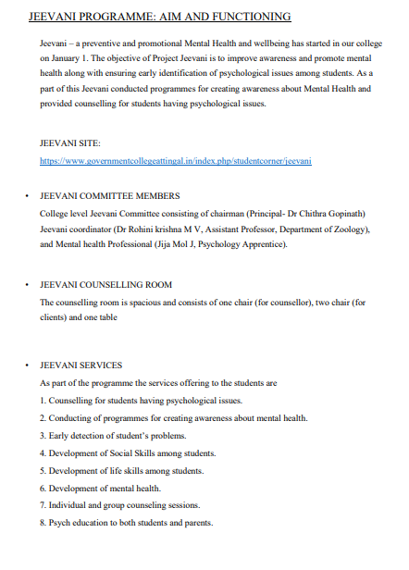

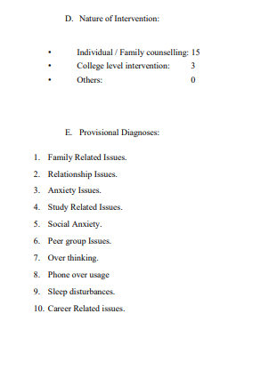
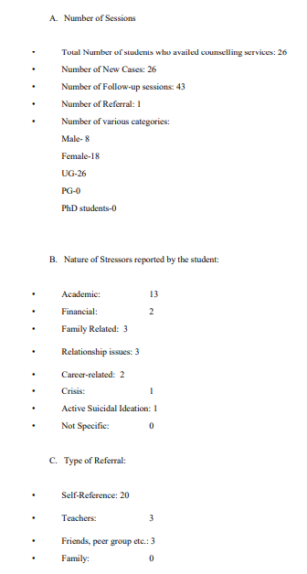

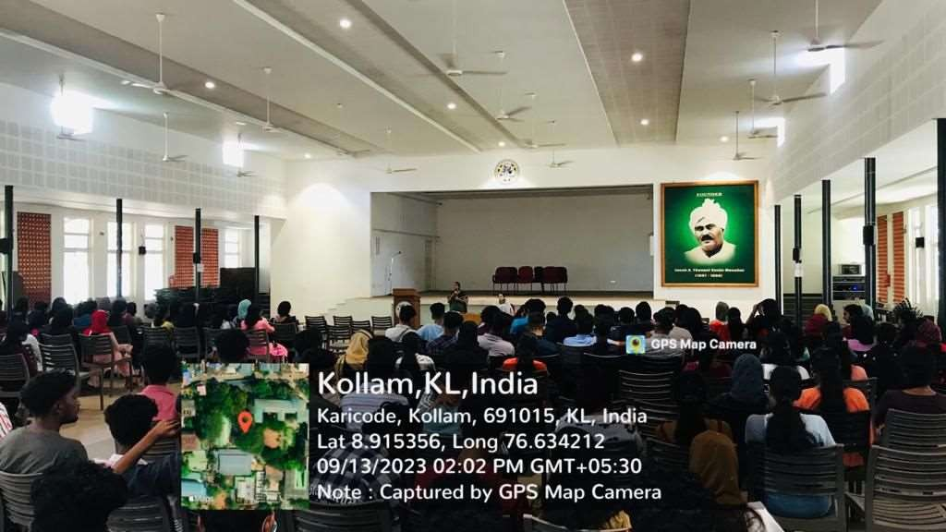

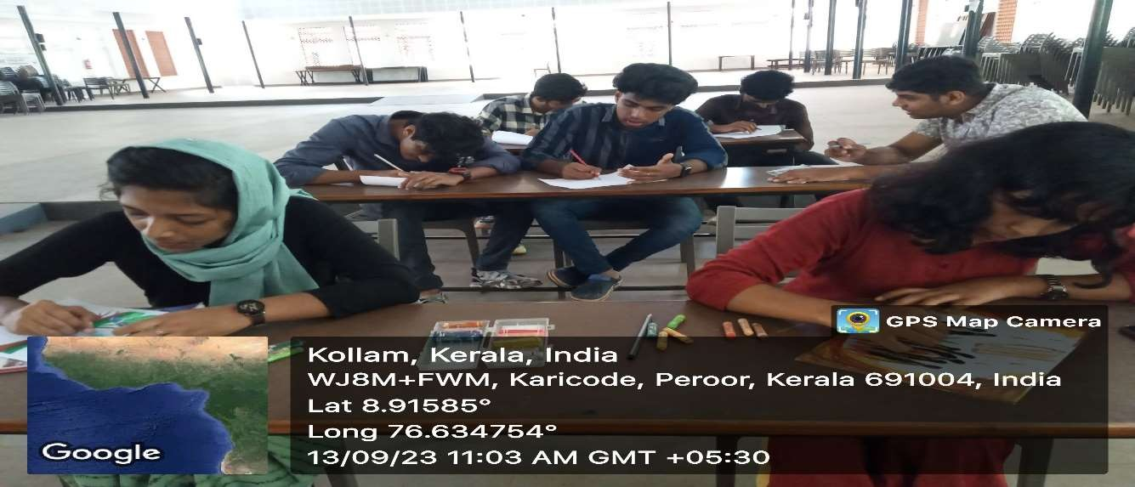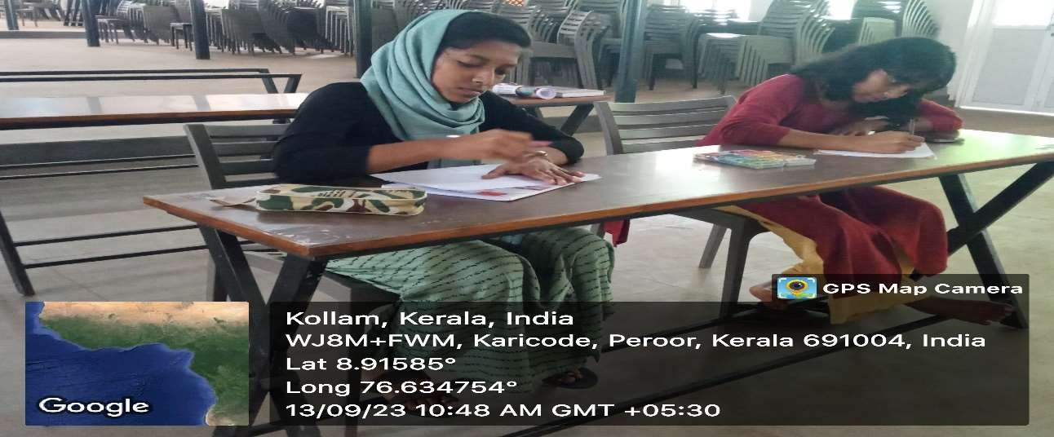

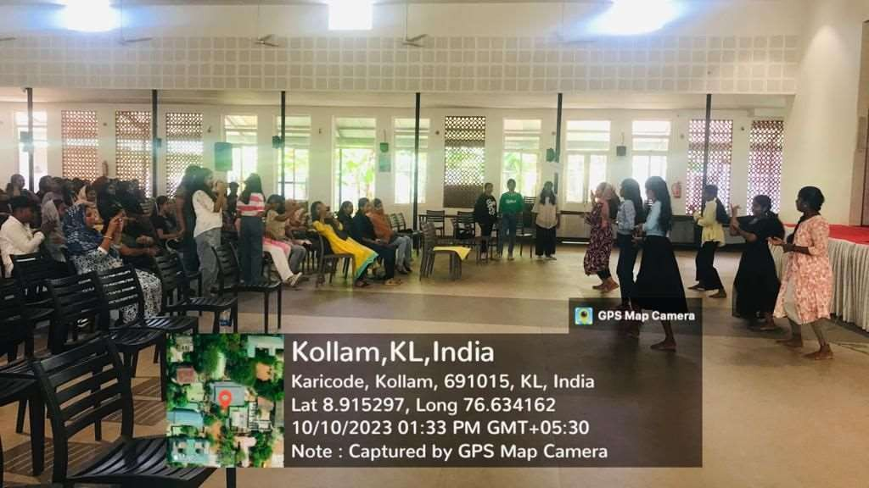
Under the guidance of CACEE (Centre for Adult Continuing Education and Extension), Microsoft Office Programmes are provided to students to develop valuable skills and knowledge. These programmes help students become proficient in using Microsoft Office tools such as Word, Excel, PowerPoint, and Outlook. Such programmes can be incredibly beneficial for both personal and professional development.

Sl. No. | Name | Reg. No. | Department | Semester 3 | Semester 4
1. | Fathima A. | 24522142025 | Botany | 20 | 20
2. | Fathima K. | 24522142026 | Botany | 20 | 20
3. | Shibina B. | 24522142034 | Botany | 20 | 20
4. | Safeer Muhammad | 15922142106 | B.Com C.A. | 20 | 20
5. | Hana J. Pampalil | 24522142030 | Botany | 20 | 20
6. | Aisha N. | 14122142034 | Islamic History | 20 | 20
7. | Amina S. | 14122142038 | Islamic History | 20 | 20
8. | Muhammed Ali Jouhar | 14122142047 | Islamic History | 20 | 20
9. | Muhammad Sajad S. | 24522142006 | Botany | 20 | 20
10. | Gayathry S. | 24522142029 | Botany | 20 | 20
11. | Jayalekshmi B. | 24522142031 | Botany | 20 | 20
12. | Anshad S. | 14922142014 | Economics & Mathematics | 20 | 20

COACHING/ASSISTANCE AT THE DEPARTMENT LEVEL FOR QUALIFYING/ENTRANCE EXAMINATIONS

Students are given coaching/assistance for cracking qualifying examinations (like NET, SET, SLET, GATE) as well as entrance tests for admission into various state research departments as well central universities.

CAREER GUIDANCE COUNSELLING AT DEPARTMENT LEVEL AND IQAC-LEVEL
National Workshop on Fundamentals and Applications of Spectroscopy
The Department of Biochemistry in collaboration with the Research Cell and IQAC of TKM College of Arts and Science, Kollam, Kerala, India, organized a National Level One- Day Workshop on "Fundamentals and Applications of Spectroscopy." on August 11, 2023. The primary objective of the workshop was to provide participants with a comprehensive understanding of the principles and practical applications of spectroscopy across diverse fields. The workshop aimed to enhance attendees' knowledge and ensure they remain abreast of the latest advancements in spectroscopic techniques. Dr. Ajith Kumar A. from the Indian Institute of Science (IISc), Bangalore, delivered an enlightening presentation on "Characterizing Visible and Invisible Proteins Using Solution NMR Spectroscopy."
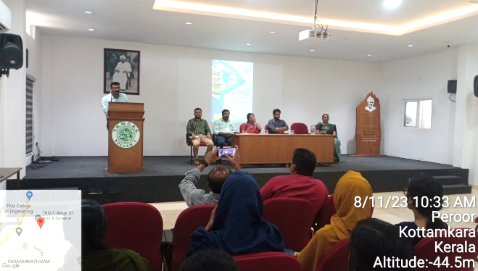 | 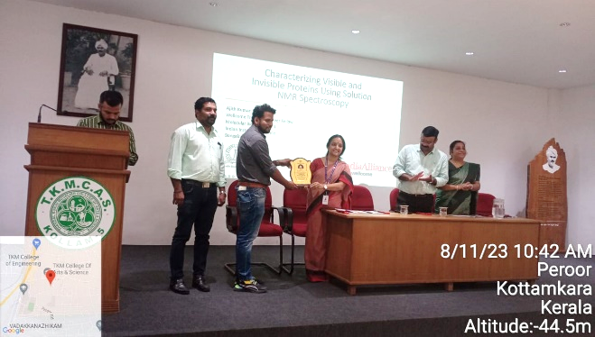
Moments from the Fundamentals and Applications of Spectroscopy Workshop
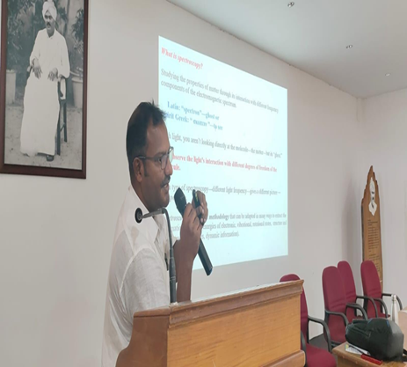 | 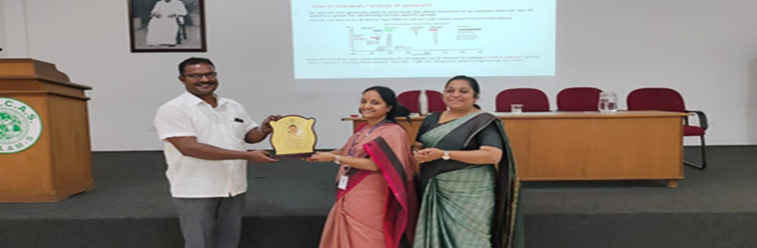
Captures from the Spectroscopy Workshop
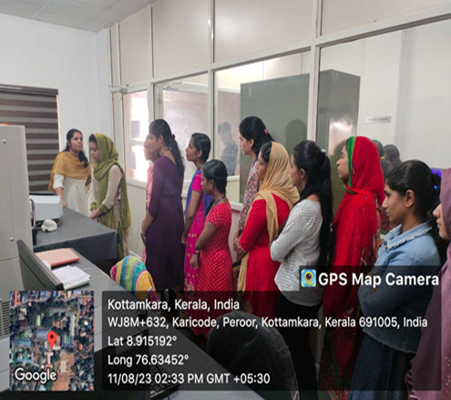 | 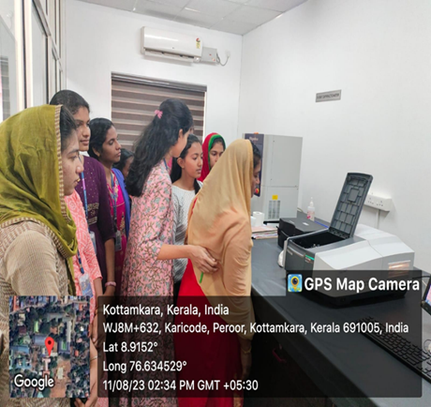
Hands-on demonstrations of various spectroscopic instruments
The event succeeded in its mission to impart valuable insights into the principles and practical applications of spectroscopy, equipping attendees with the knowledge and skills to remain at the forefront of advancements in this field.

Academic Training for Life Science Students
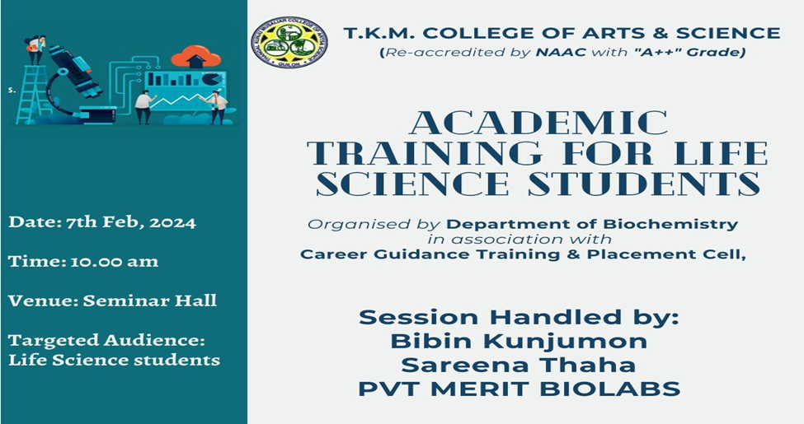

The Departments of Biochemistry and Zoology, in collaboration with the Placement Cell of T.K.M. College of Arts and Science, organized an Academic Orientation Programme for students of Biochemistry and Zoology on 7th February 2024. Held at the Zoology Laboratory, the event was conducted in association with Merit Biolabs Pvt Ltd and Seto International Training and Consultancy, aiming to highlight the importance of the HACCP course and the career opportunities it offers. Mrs. Sereena Thaha (Seto International Training and Consultancy emphasized how this internationally recognized certification can open doors to high-quality, well-paid jobs in India and abroad.
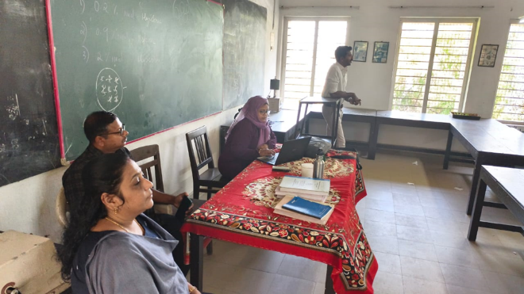 | 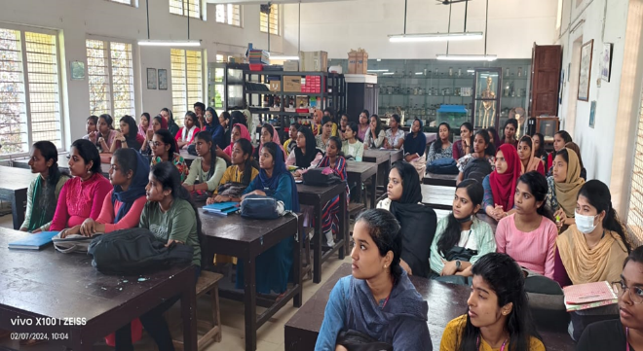
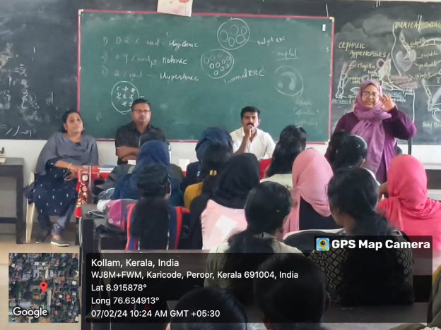 | 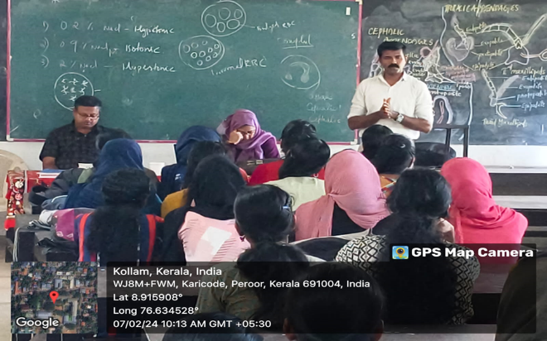
Orientation Program for Life Science Students

The event also featured an engaging interactive session, where students posed their queries to the resource persons. This open dialogue helped clarify various aspects of the training and career opportunities discussed.
This orientation programme successfully provided students with a comprehensive understanding of career prospects in life sciences, inspiring them to strive for excellence and make informed decisions for their future endeavors.

JOB ORIENTATION PROGRAMME ON “INTRODUCTION TO PATENTS AND CAREER OPPORTUNITIES’’
The "Job Orientation Programme on Introduction to Patents and Career Opportunities" was organized on the 31st of July 2023, 12.00 PM at the Multimedia Lab of T.K.M. College of Arts and Science in Kollam, Kerala, India. The event was organized by the Department of Biochemistry in collaboration with the Career Guidance Training and Placement Cell.
The Controller General of Patents, Designs, and Trade Marks (CGPDTM) has recently announced the CGPDTM Patent Examiner Recruitment 2023, offering a remarkable opportunity to recruit 553 Patents & Designs Examiners. Recognizing the significance of this opportunity, the Department of Biochemistry, in collaboration with the Career Guidance Training and Placement Cell of T.K.M College of Arts and Sciences, organized a Job Orientation Programme to empower prospective candidates to make the most of this exceptional career opportunity. The program was specifically designed to assist Biochemistry, Chemistry, and Physics postgraduate students in their preparation for the CGPDTM Patent Examiner Recruitment.
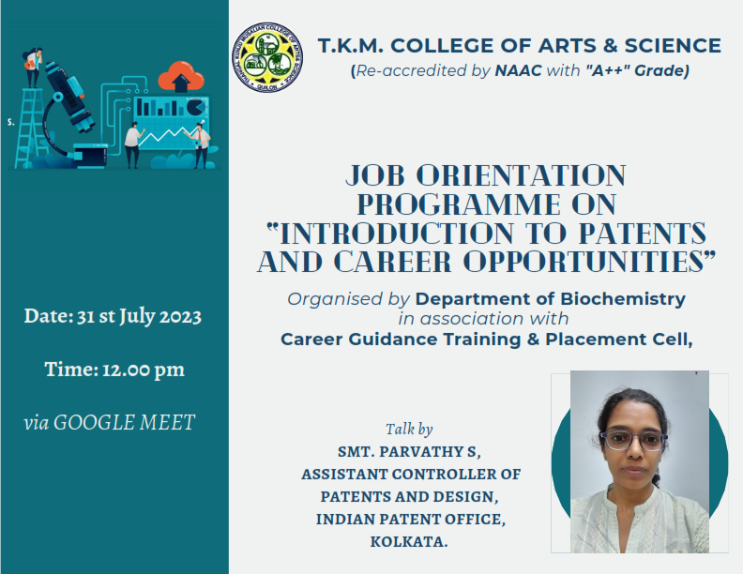
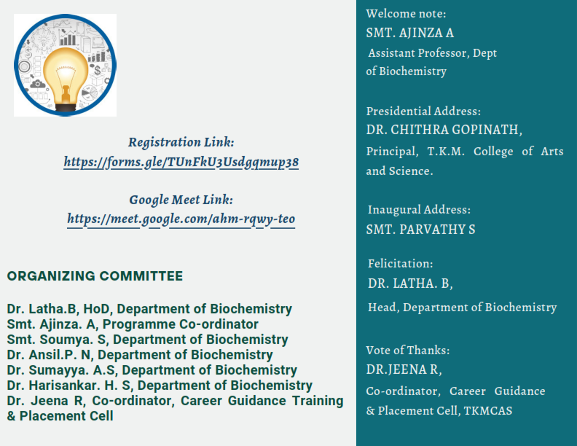
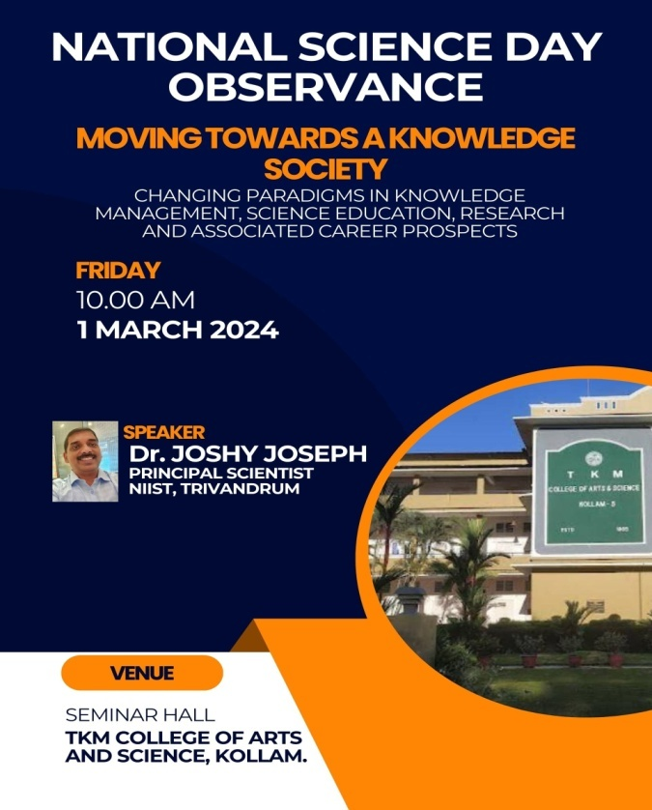
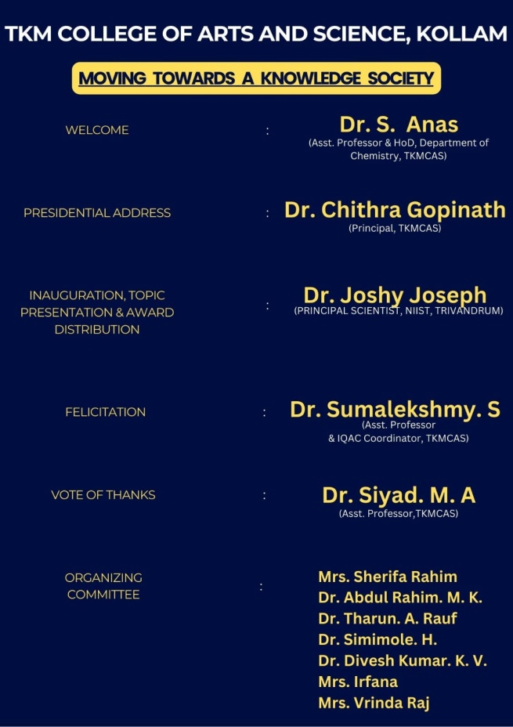

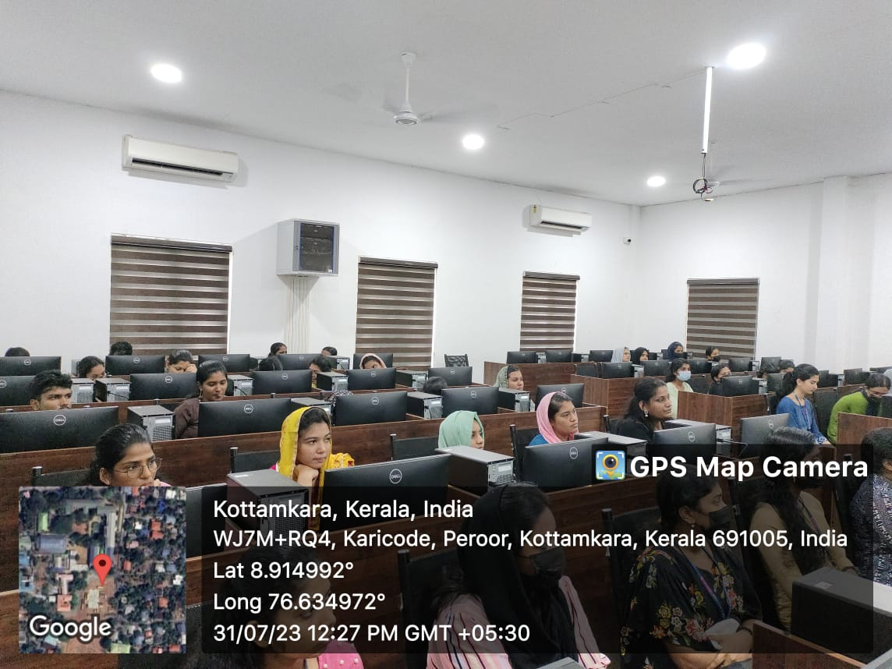 | 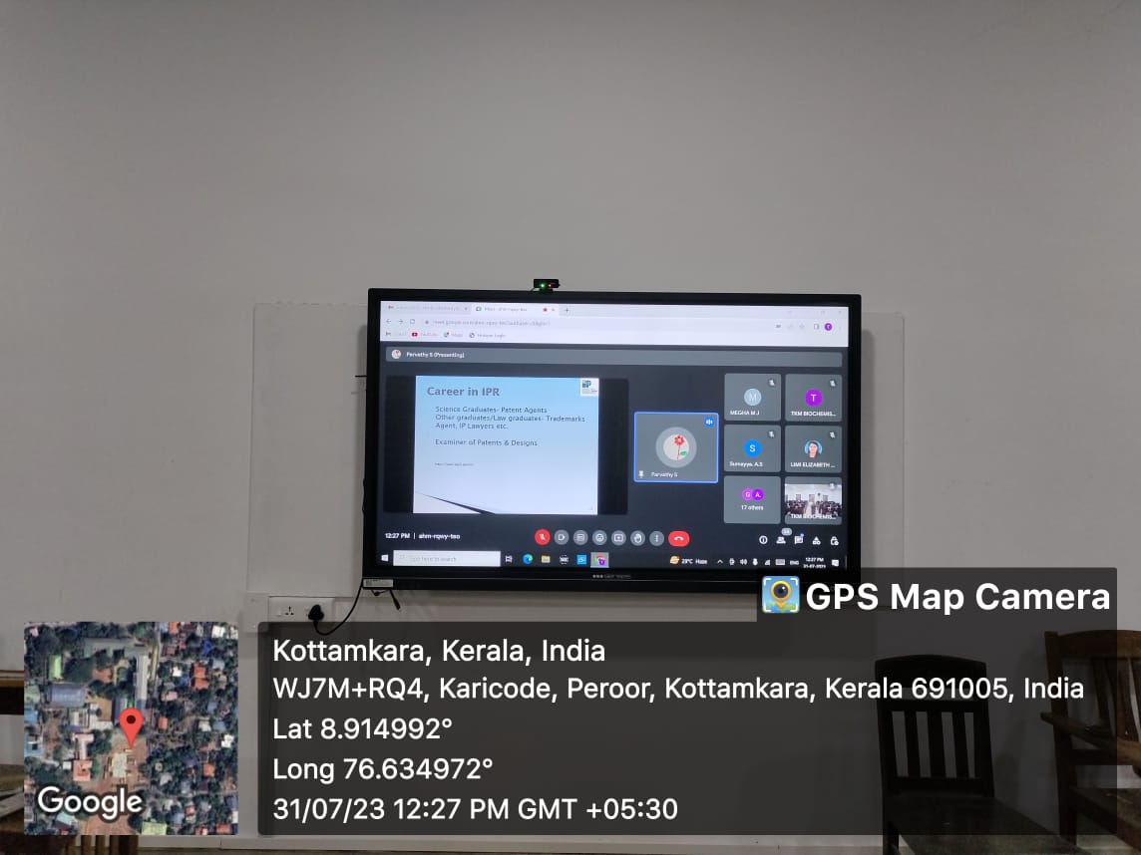

Career guidance moving towards knowledge society

On March 01 2024, Dr. Joshy Joseph, Principal Scientist and Associate Professor at NIIST, Trivandrum delivered an insightful seminar to college students on the topic of "Science Education and Career Advancement". The event, organized by the Dept. of Chemistry aimed to provide students with a comprehensive understanding of how science education can shape their future career paths and the various strategies they can employ to succeed in a competitive job market.

INTERNATIONAL CONCLAVE ON US TAX CAREERS

Initial meeting with ASAP Kerala by the faculties of Department of Commerce on 9th February, 2024 for organizing the event
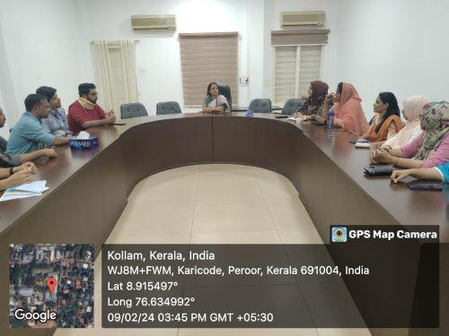
In continuation of the visit of the Honourable Chief Minister of Kerala to the US in June 2023, during which he engaged with leaders of industry in the fields of finance and taxation, TKM Group of Institutions and Additional Skill Acquisition Programme, Kerala (ASAP, Kerala), a Government of Kerala Company under the Department of Higher Education, were jointly organized an International Industry-Academia Conclave on opportunities in US Taxation. The Conclave was held on 17th February 2024. This program was chaired by Dr. Usha Titus IAS (Retd), Chairperson & Managing Director, ASAP Kerala.
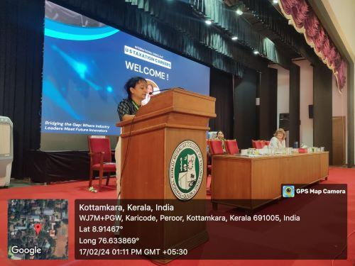

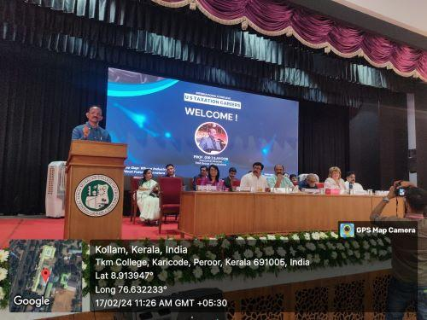
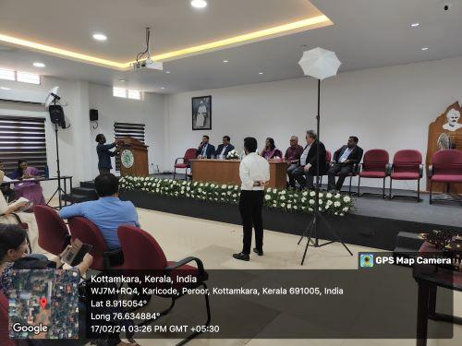
Valedictory Function at TKM College of Arts and Science
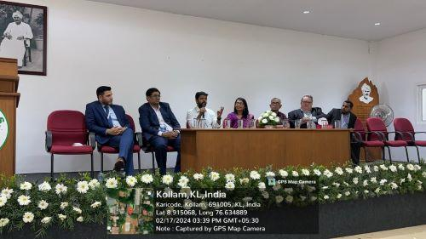
Student interaction with representatives from top US accounting firms such as H&R Block, KPMG, Ernst & Young, GR8 Affinity, Nexdigm, and GT

CAREER GUIDANCE SESSIONS CONDUCTED WITH MOU PARTNERS -LOGIC SCHOOL OF MANAGEMENT AND ISDC

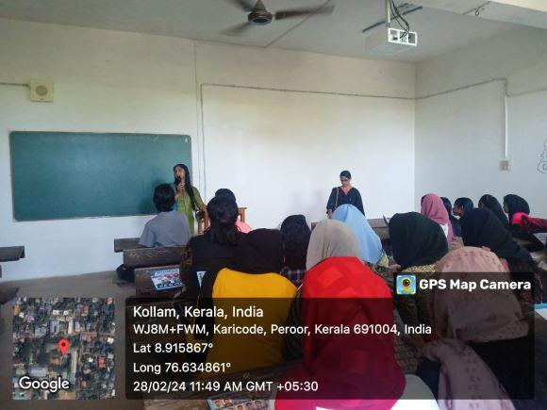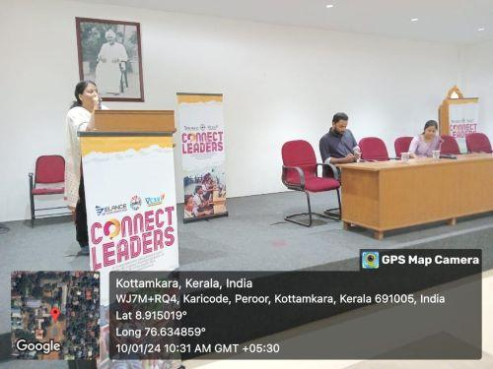
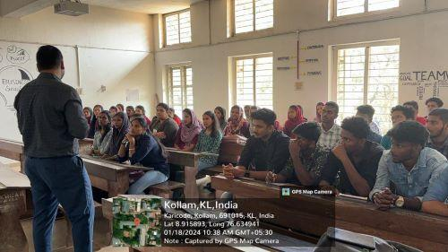

IMPLEMENTATION OF DIGICOL (GOK INITIATIVE)

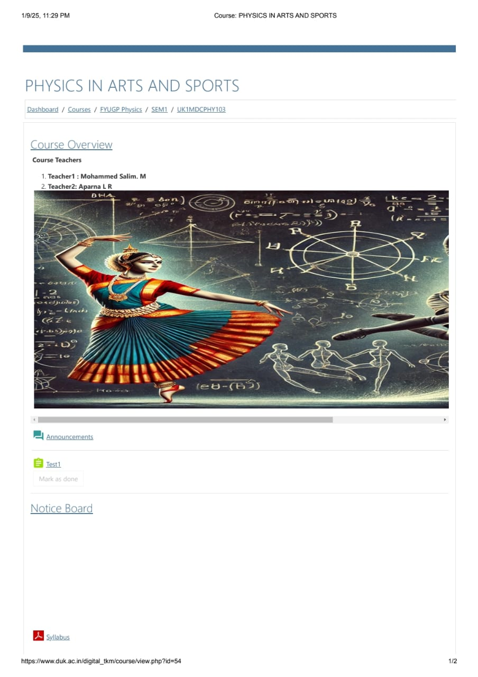
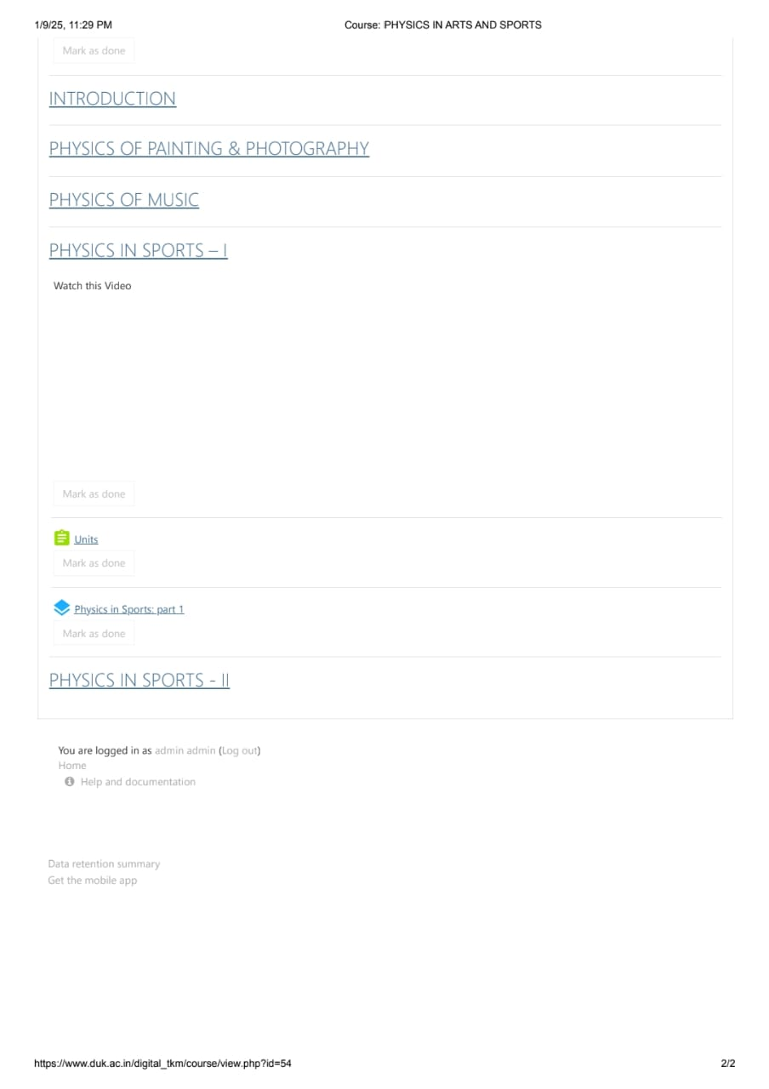

EVIDENCE OF SUCCESS
- The details of Faculty Training Programmes organized by IQAC are given below:

Year | No. of programmes
2019-20 | 14
2020-21 | 10
2021-22 | 04
2022-23 | 05
2023-24 | 07

- College is one among ten institutions shortlisted for Let’s Go Digital DigiCol initiative of the Government of Kerala. Under this scheme, the college can avail MOODLE server space and LMS sponsored by the government.
- The number of certificate courses offered by various departments have risen progressively in the last five years. The details are given below:

Year | No. of certificate courses
2018-19 | 14
2019-20 | 26
2020-21 | 32
2021-22 | 33
2022-23 | 30
2023-24 | 29

- The college has registered for G-Suite account and user IDs created for all faculty members and students. Every faculty member has a dedicated online platform (Google Classroom, Moodle, College LMS account) for sharing study materials, PowerPoint presentations and video lectures with students.
- The student community uses NList services provided by the college library to access resources for preparation of assignments, projects.

Problems Encountered and Resources Needed
Sl No. | Problems Encountered | Resources Needed
1 | Hesitation among students to adopt a blended learning system | Teachers organized informal online sessions to familiarize the students with various online educational resources; peer assisted learning was also encouraged.  Resources needed: 100 percent digital access for all students
2 | Digital literacy among teaching and non-teaching staff | Technical assistance from support staff
3 | Teachers find it difficult to attend Faculty Empowerment Strategies due to the hectic CBCS academic calendar | Schedule to ensure all faculty members get equal opportunities to attend seminars/workshops/Faculty Development Programmes on a rotation basis

