DEPARTMENT OF PHYSICS

COURSE COORDINATOR
Aparna L.R.
Assistant Professor

CERTIFICATE COURSE IN GOOGLE PLUGINS

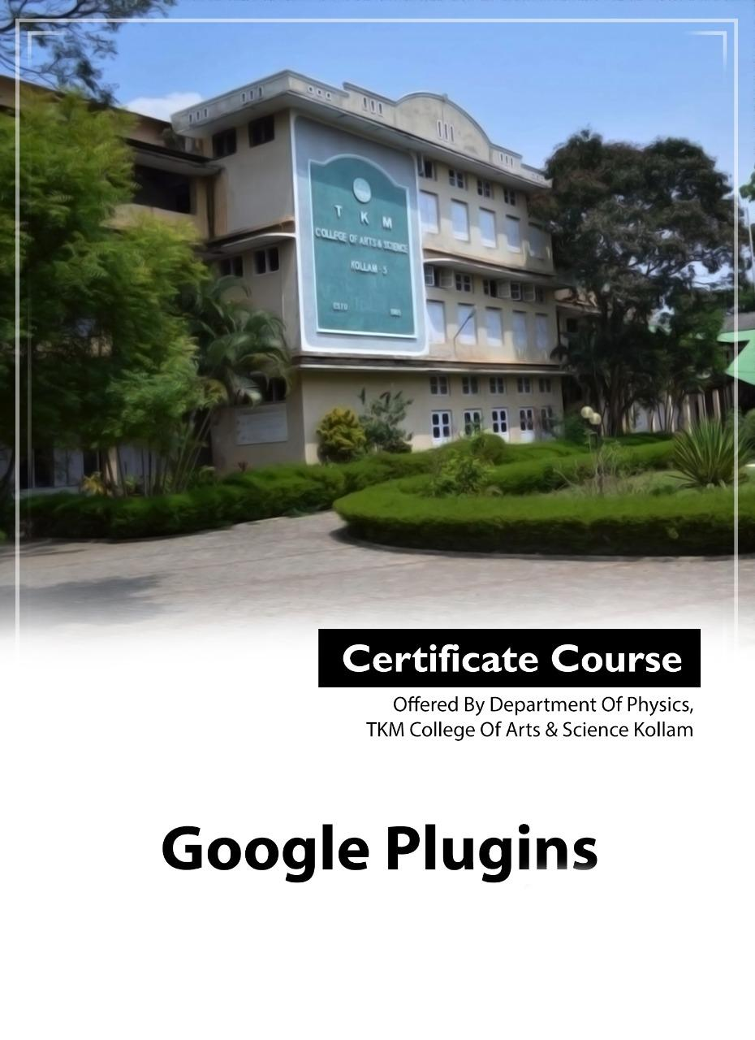
Attendance Statement
Google Plugins- S2 BSc (2023-26) – Academic Year 2023-24
(Class Time- 9.30 am-3.30 pm)
Name | 1.4.2024 | 2.4.2024 | 3.4.2024 | 4.4.2024 | 5.4.2024 | 8.4.2024 | % attendance
Name | 9.30-3.30 | 9.30-3.30 | 9.30-3.30 | 9.30-3.30 | 9.30-3.30 | 9.30-3.30 | % attendance
A. Amal | P | P | P | P | P | P | 100
Abhirami A. R. | P | A | P | P | P | P | 83
Abid Khan S. | P | P | P | P | P | P | 100
Akhil N. | P | P | P | P | P | P | 100
Alfiya M. | P | P | A | P | P | P | 83
Devika L. H. | P | P | P | P | P | P | 100
Devika S. J. | P | P | P | P | P | P | 100
Hajira S. | P | P | P | P | P | P | 100
Harin Raj A. S. | P | P | P | P | P | P | 100
Hashmi S. H. | P | P | P | P | P | P | 100
Kavya Gopan | P | P | P | P | P | P | 100
Lekshmi Krishna C. | P | P | P | A | P | P | 83
Parvathymol V. M. | P | P | P | P | P | P | 100
S. Amrin Fathima | P | P | P | P | P | P | 100
Sreenu R. S. | P | P | P | P | P | P | 100
Sreeram M. R. | P | P | P | P | P | P | 100
Abhiram S. J. | P | P | P | P | P | P | 100
Adithya Sunil | P | P | P | P | P | P | 100
Adithyan S. J. | P | P | P | P | P | P | 50
Anjana Krishnan S. | P | P | P | P | P | P | 100
Arya Anil R. | P | P | P | P | P | P | 100
Asna S. Khan | P | A | P | P | P | P | 83
Aswin S. Kumar | P | P | P | P | P | P | 100
Muhammed Hassan A. | P | P | P | P | A | P | 83
Navya Binu | P | P | P | P | P | P | 100
Neha Binu | P | P | P | P | P | P | 100
Niranjana D. S. | P | P | P | P | P | P | 100
S. R. Arya Nair | P | A | P | P | P | P | 83
Vaishnavi M. S. | P | P | P | P | P | P | 100
Jaseena J. | P | P | P | P | P | P | 100

Course Coordinator : Aparna L.R.
Assistant Professor
TKM College of Arts and Science, Kollam
Department of Physics - Certificate Course for S2 BSc 2023-26
Syllabus Certificate Course – Google Plugins

Course Duration : 30 Hrs
Type of course : Computer Application
Prerequisite : Basics in computer, internet, MS Office
Unit I Account Creation
Basics of Internet- Gmail Account creation- Different Application in Gmail-Importance of
Collaborative works
Unit II Google Applications
Google Drive- Usage, File &amp; Folder Creation, Organization of folders, Storage Space, Uploading data, Editing data, Sharing files

Google Doc-Introduction to MS Word, How to create a doc file, open an existing file, save a file, how to use different templates- voice typing, translate-formatting Text files-download and export in-different format like .txt ,pdf, HTML etc

Google sheet- Introduction to Excel- Usage, File creation- How to create a sheet, open an existing file, save a file Inserting rows and column, deleting columns and rows-use of equation for analysis–graphical analysis-download and export in different format like .txt ,pdf, HTML etc

Google classroom- Google Meet- Google Blogger

References:

Course Outcome:
After learning the course the students will be able to:
1) Use Google drive effectively
2) Do documentation using Google Docs.
3) Do data analysis using Google sheets
4) Use Google classroom effectively
Teaching methods
Classroom Teaching, Lab Sessions
The theoretical part of the course is also presented in the Google classroom in the form of presentation, lecture notes and video presentation and shared videos.

Assessment
The course grade consists of these components:
60% – Knowledge test with multiple choice questionnaire
40% – Assignment

TKM College of Arts &amp; Science, Kollam
Department of Physics

S2 BSc Physics 2023-26 Academic Year 2023-24
Report on Certificate Course – Google Plugins.

Department of Physics TKM College of Arts & Science conducted 30 Hr. Certificate Course on “Google Plugins”. A total of 30 students of S2 BSc (2023-26) batch were enrolled in the course. The course coordinator was Dr. Mohammed Salim. The course was offered through Class Lectures & Google classroom. The classes are handled by Aparna L R, Assistant Professor, and Department of Physics. The classes started on 1st April 2024. Each day contains 6 teaching hours. Both theory as well as practical sessions were arranged. An assessment test containing multiple choice questions was conducted on 9th April for issuing certificates. All the students successfully completed the certificate course.

Grades
90% and above - A Grade
80-89% - B Grade
70-79% - C Grade
60-69 % - D Grade

19 Students secured A grade whereas 7 students secured B Grade and 4 students secured C grade.

Course Instructor : Aparna L R, Assistant Professor, Department of Physics

Course Coordinator : Dr. Mohammed Salim, Assistant Professor,
Department of Physics

Google Plugins- S2 BSc (2023-26) – Academic Year 2023-24
Grade Sheet

Sl. No. | Candidate Code | Admission Number | Name of the student | Grade
1. | 23023142001 | 59329 | A. Amal | C
2 | 23023142002 | 59597 | Abhirami A. R. | B
3 | 23023142003 | 59549 | Abid Khan S. | B
4 | 23023142004 | 59525 | Akhil N. | C
5 | 23023142005 | 59333 | Alfiya M. | B
6 | 23023142006 | 59230 | Devika L. H. | A
7 | 23023142007 | 59216 | Devika S. J. | A
8 | 23023142008 | 59443 | Hajira S. | B
9 | 23023142009 | 59224 | Harin Raj A. S. | A
10 | 23023142010 | 59355 | Hashmi S. H. | B
11 | 23023142011 | 59213 | Kavya Gopan | B
12 | 23023142012 | 59217 | Lekshmi Krishna C. | A
13 | 23023142013 | 59537 | Parvathymol V. M. | A
14 | 23023142014 | 59639 | S. Amrin Fathima | C
15 | 23023142015 | 59206 | Sreenu R. S. | C
16 | 23023142016 | 59233 | Sreeram M. R. | A
17 | 23023142017 | 59240 | Abhiram S. J. | A
18 | 23023142018 | 59239 | Adithya Sunil | A
19 | 23023142019 | 59241 | Adithyan S. J. | A
20 | 23023142020 | 59538 | Anjana Krishnan S. | B
21 | 23023142021 | 59533 | Arya Anil R. | A
22 | 23023142022 | 59586 | Asna S. Khan | A
23 | 23023142023 | 59364 | Aswin S. Kumar | B
24 | 23023142024 | 59336 | Muhammed Hassan A. | B
25 | 23023142025 | 59248 | Navya Binu | A
26 | 23023142026 | 59320 | Neha Binu | A
27 | 23023142027 | 59238 | Niranjana D. S. | A
28 | 23023142028 | 59540 | S. R. Arya Nair | A
29 | 23023142029 | 59467 | Vaishnavi M. S. | A
30 | 23023142030 | 59585 | Jaseena J. | A

